Submission to:
Review of rail coal dust emissions management practices
in the NSW coal chain

Nick Higginbotham, PhD
Centre for Clinical Epidemiology & Biostatics
School of Medicine & Public Health
The University of Newcastle
Newcastle, NSW

20 October, 2015

Newcastle air quality is poor, particularly along the coal rail corridor (Beresfield) and within portside suburbs (Newcastle/Stockton), as shown by EPA monitors over the past six years (see Dr Ben Ewald’s presentation to Chief Scientist);

In light of this, my submission makes five key points:

- Coal rail transport is a source of significant diesel combustion and coarse fraction particulate emissions in an already polluted air shed, exposing large suburban populations to harmful particulate matter;

- NSW state government has just approved an additional 70 million tonnes of coal shipments, requiring a further 19,400 train movements along the coal chain on top of the 58,254 movements presently approved;

- The NSW EPA offers no mitigation measures for reducing coal train emissions. It endorses the methodologically flawed 2013 ARTC trackside monitoring data to claim that coal and freight trains have the same emissions, diesel exhaust is not responsible for pollution increases as trains pass, and the source of any increased pollution is existing dust along the tracks.

- These conclusions are unjustified and mislead the public. Because a single monitor was placed on one side of the track—nearest to the freight line—the ARTC study suffered systematic measurement error precluding comparison of different train types. The magnitude of pollution increases from trains, when the wind is blowing towards the monitor, is still unknown.

- These two problems, plus the uncertainty of knowing when a train actually arrived at the monitor (See Dr Ewald’s submission), undermine conclusions about diesel exhaust not being important and stirring up track dust as the main source of emissions.

Introduction
- Below are excerpts highly relevant to the Chief Scientist’s initiative, that are taken from a report I prepared for the Environmental Defenders Office (EDO) NSW. This comprised independent expert advice on impacts of the proposed development of a fourth terminal at Kooragang Island (T4 project) on public health. I wrote this report adhering to the Expert Witness Code of Conduct under the Uniform Civil Procedure Rules 2005, and based on my 26 years of experience working as an Associate Professor of public health at the Centre for Clinical Epidemiology and Biostatistics, School of Medicine and Public Health, University of Newcastle.
EDO Report Summary:
- Access to clean air is a public health necessity. In my view, air pollution from coal transport and handling operations for T4 is a significant threat to public health because:
- The transport and loading of an additional 70 million tonnes annually will worsen air quality around Newcastle that already exceeds WHO and national guidelines;
- T4 requires 19,420 additional coal train movements through Hunter suburbs, beyond the 58,250 annual coal train movements already approved;
- Diesel powered coal trains are a major source of toxic pollution, entraining uncontrolled carcinogenic diesel exhaust combined with harmful particulate matter (PM10 and PM2.5);
- Approximately 32,000 house residents and 23,000 school children attending schools within 500m of the coal corridor (between the Port and Rutherford) will be exposed to even greater concentrations of coal rail pollution; mitigation measures for this source have not been sought by government authorities in relation to T4;
- No Health Impact Assessment was completed to learn how T4 hazards could potentially harm nearby residents who are already exposed to unacceptable levels of industrial pollution; they are among the most vulnerable in society; rank highly in hospital emergency visits for respiratory illness; and, have greater days of life expectancy loss from pollution than people living in Sydney;
- Current national air quality standards (NEPM) do not adequately protect nearby residents; health effects occur at PM concentrations lower than set standards and with short-term exposures (<24-hours); there is no compliance standard for PM2.5; and, ambient monitoring misses pollution ‘hot spots’.

- In your opinion, in the context of promoting public health, was the assessment of air quality conducted at an appropriate scale, including the full range of project related activities?

Summary
- Assessment of T4 air quality (AQ) was not conducted at an appropriate scale because it failed to fully consider impacts on residents adjacent to the coal rail corridor used for transporting coal to the facility. Modeling of cumulative pollution dispersion either side of the rail line is essential to evaluate health risks imposed on residents. An appropriate rail corridor AQ assessment would include: Total Suspended Particulates (TSP), Particulate Matter with aerodynamic diameters of 10 microns or less (PM10) and 2.5 microns or less (PM2.5), locomotive diesel exhaust, loaded and unloaded coal trains. Modeling would estimate increases in pollution concentrations (against current background levels) when the Port reaches proposed capacity of 280Mtpa (including T4, PWCS’ three other loaders, plus the Newcastle Coal Infrastructure Group loader).

Omission of Rail Corridor
- The construction of T4 is subject to a planning process, and the increase of train movements is a necessary part of the new coal loader proposal. However, the Proponent does not acknowledge train movement pollution as their responsibility. This extra transport task has potentially significant health effects but does not have its own planning review process.
- The Preferred Project Report (Vol 5 p73) states that 26.6 trains will haul 7200 tonnes of coal daily to achieve 70Mt annual volume at T4. Table 1 shows the impact of this additional 25% in rail volume to the existing and approved coal tonnage. Also shown are the cumulative daily train movements or residential ‘pass-bys’ imposed on people living near the rail corridor.

Table 1: Newcastle Port coal tonnage & daily train movements

 | Daily loaded trains | Daily round - trip pass-bys | Annual  pass-bys
Current tonnage 150Mt | 57.2 | 114.5 | 41,792
Current Approved 210Mt | 79.8 | 159.6 | 58,254
Approved plus T4 280Mt | 106.4 | 212.8 | 77,672
T4 only  70mt | (26.6) | (53.2) | (19,418)

- Coal throughput of 280Mtpa at Newcastle port requires one coal train pass-by every 6.7 minutes. Given coal trains take, on average, two to three minutes to pass by, this tonnage of coal will produce near continuous rail traffic. GIS mapping shows there are 32,000 house residents and 23,000 school children attending schools within 500m of the coal corridor (between the Port and Rutherford). The health risks to these residents and students from an ever increasing exposure to rail pollution must be comprehensively assessed prior to a PAC determination of this project, in my opinion.

Evidence of train line pollution
- Loaded and unloaded coal trains moving along the coal corridor (and within the T4 site) remain a significant and poorly understood source of harmful emissions from: 1) diesel combustion; 2) wind erosion of loaded coal wagons and wind scouring of residual coal dust from empty wagons; 3) re-suspension of coal dust spilled along the corridor and other dust sources; and 4) entrainment of all of these particulates and their dispersion into the ‘air shed’ or air supply covering the rail corridor location.
- The world literature estimates that from 0.001% to 1% of the coal load is lost during transport (e.g., Ferreira et al., 2003; one estimate is 3%, BNSF, 2011). Ferreira et al. (2003 & 2004) found that uncovered wagons could emit up to 5 times more than semi-covered wagons, or 8.57g/km/wagon (Connell Hatch, 2008). Extensive load losses can even destabilize ballast, causing derailment (BNSF Railway) in the USA: http://www.bnsf.com/customers/what-can-i-ship/coal/coal-dust.html).
- Entrainment of carcinogenic diesel combustion emissions plus fugitive coal dust has the potential to expose residents living near the rail line to particulate pollution depending on their distance from the track, weather, moisture, wind speed and direction, train speed and the number of train pass-bys (Connell Hatch, 2008; CTAG, August, 2013).
- Connell Hatch made estimates of dust emissions from several Queensland coal transport systems (Connell Hatch, 2008; p40-42). They found that movement of 151Mtpa of coal in 2006/07 resulted in losses of 5370 tonnes of coal (as TSP). Predicted movement of 225.6 Mtpa of coal in 2014/15 will result in 7814 lost tonnes. Hence, an additional 74 million tonnes of coal moving through this transport system (i.e., about the same as T4) will produce a 40% increase in TSP fugitive emissions, adding 2,414 further tonnes into the air shed along the track. They also note train speeds are a critical factor in emissions; an average increase in speed of 10 km/hr would produce a 41% additional increase in tonnes of TSP.
- While conditions in Queensland are not the same as the Hunter, study findings do suggest that particulate concentrations will likely double from present levels, if the coal industry’s aspirations for 280Mt throughput (with T4) are realised.

Train pollution concentrations
- Given the number of residents and children located close to the rail corridor, and the projected increased frequency of coal train pass-bys
(1 @ 6.7 minutes), how much pollution does each train contribute to the air shed during a pass-by and what are the concentrations hourly, daily, yearly?
- PWCS partially addressed this topic by applying Ferreira et al.s’ (2003) fugitive emissions estimates (as per Connell Hatch study) to estimate peak 24-hour PM10 concentrations of coal trains on route to T4. For a coal delivery rate of 70Mtpa, PM10 peak 24-hour concentrations were predicted to be in the range of 1.5 to 6.4 ug/m³ at a distance of 20m from the railway corridor. Based on this estimate and an ARTC pilot study report, PWCS concludes: “coal dust entrainment is not projected to result in significant air quality impacts along the rail corridor (ENVIRON, 2013, Appendix O, p. 4).” NSW Planning accepts this ‘qualitative assessment’, considers the impacts as ‘relatively modest’, and notes the EPA is the appropriate manager (NSW P&E, 2014, p. 21).
- I believe this is a gross underestimate of particulate concentrations because it leaves out several significant pollution sources: returning unloaded trains; diesel exhaust emissions; PM2.5 (which is a component of PM10); as well as cumulative emissions and background pollution.
- First, the estimate does not include 26.6 daily unloaded coal train pass-bys, which are likely to have higher emissions due to faster average speed and greater carriage surface area exposed to wind scouring of residual (and dry) coal in the carriages. Connell Hatch (2008, pg 30; citing CSIRO et al., 2007) note that, “on average, the worst-case coal carry-back [i.e., unloaded train returning to the mine] was found to be 0.13 tonnes per wagon.”
- Second, fine particulates (PM2.5 and smaller) were not considered. PWCS states that “concentrations are projected to reduce significantly with increasing distance from the rail corridor.” However, a characteristic of PM2.5 is longer airborne time, wider area coverage (Hibberd et al., 2013), and strong links with a range of diseases and mortality (Pope et al., 2009).
- Third, and most importantly, PWCS’ conclusion does not consider locomotive diesel emissions. The majority of coal trains are configured with three diesel locomotives, and virtually none of them have any PM emission controls (PPR, Air Assessment Appendix O, pg 73). Indeed there are no regulations to limit locomotive exhaust in Australia, although the NSW EPA note that locomotive emissions are a significant contributor to particle levels (EPA, 2014, p 6). WHO classifies diesel engine exhaust (DEE) as a human carcinogen (IARC, 2013). DEE is a “complex mixture of substances characterised by polycyclic aromatic hydrocarbons (PAH) surrounding an elemental carbon core (Rushton, 2012, p1).”
- [Diesel exhaust can be detected 1-2km away if the air is clean, and 200-300m if not (B. Brunekreef, 2013).]
- Fourth, the rail corridor now transports over 150Mtpa into the Port (Transport for NSW, 10 Jan 2014). What is the current background pollution level, what will the level rise to with the addition of T4, what pollution levels will be reached when the corridor transports 280Mtpa, requiring 77,672 pass-bys each year through Newcastle suburbs? I believe knowledge of this cumulative impact is critical for making decisions about the Port’s future.

ARTC studies of rail corridor pollution
- The ARTC commissioned two studies to address this issue, a pilot study (Environ, Sept. 2012) in two locations and a follow-up study at Metford (Katestone, May 2013). Methodological problems in the pilot study resulted in inconclusive findings. Two independent reviewers found that the Katestone study required further statistical analysis, and Prof Louise Ryan did so, releasing a report on 26 February 2014.
- Prof Ryan’s reanalysis of the Katestone/ARTC data set concluded there was “clear evidence that particulate levels were elevated when trains passed by the monitoring station. Effects were strongest and of a similar magnitude (approximately 10% increase above background levels) and highly statistically significant for freight and coal trains, both loaded and empty. The effects for passenger trains were mostly significant, but of a smaller magnitude (Ryan & Wand, 2014, pg 3).”
- While several methodological limitations undermine the Katestone study (see below), it offers information that may shed light on coal corridor pollution. Over the December to January 2013 recording periods, the average background particulate level (no train present) for TSP was 37.4ug/m³. When readings were restricted to times when the wind blew past the tracks towards the Osiris air quality monitor, the levels rose to 43ug/m³ (a 15% increase).
- Prof Ryan used a more conservative criterion for No Trains (background levels). Yet, she also found TSP rose from 26.28ug/m³ to 33.41ug/m³ when wind is blowing toward the monitor -- an increase of 27%. Unfortunately, this is the only analysis Prof Ryan reported of magnitude increases when wind is blowing toward the monitor.
- Prof Ryan adjusted for time of day and day of week and calculated that the average increase in TSP concentrations from a loaded coal train pass-by was 2.4ug/m³. Katestone gave this average increase as 3.2ug/m³ in all wind directions and 6ug/m³ when blew toward the monitor. (See below for further analysis of the ARTC study.)

CTAG trackside Osiris monitoring
- The Coal Terminal Action Group (CTAG) undertook Osiris trackside monitoring in July 2013 to address Katestone’s methodological problems by:
1) Locating the monitor downwind of the rail line;
2) Calibrating the monitor with the nearby Beresfield EPA site;
3) Having Osiris Industry expert Mike Fry supervise the instrument deployment;
4) Including two sites (Beresfield & Hexham) to increase variability in train circumstances; and,
5) Undertaking intensive observations of trackside conditions throughout the period the monitor was in place. Seventy coal trains were measured during three days of monitoring, plus passenger and freight trains.
- Table 2 summarises the contribution of coal train pollution above background levels by subtracting a standardised 2-minute average of recorded pass-by particulates with a two-minute prior period when no train was present (CTAG, August 2013).

Table 2: Coal train particulate increases above background
Levels (average ug/m³) (CTAG, August 2013)
 | PM10 loaded  Coal train | PM10 unloaded coal train | PM2.5 loaded coal train | PM2.5 unloaded coal train
Monday 15/7/13  Beresfield | 11.8ug/m³  (n=9)  13m from monitor | 22.4ug/m³  (n=11)  9m from monitor
Tuesday  16/7/13  Hexham | 7.2ug/m³  (n=13)  24m from monitor | 18.9 ug/m³  (n=11)  27m from monitor | 2.9ug/m³  (n=13)  24m from monitor | 7.1ug/m³  (n=11)  27m from monitor

- While Prof Ryan’s 2014 re-analysis and CTAG study used different methods for determining average increases, both indicate per train contributions are significant sources of constant corridor pollution. CTAG’s average increases are much higher, possibly due to placing its monitoring downwind of the track plus the background levels in July were much lower than the No Wind averages from the Katestone/ARTC data.
- Modeling these concentrations from trains passing by every 6.7 minutes, with an already high corridor background level, suggests the PWCS figures on air quality impacts along the rail corridor (peak 24 hour PM10 of 1.5 to 6.4ug/m³) are substantially underestimated (Environ, 2013, Appendix O, pg. 46).

Train Pollution Signatures
- The unique contribution of the CTAG trackside monitoring is its intense scrutiny of each train pass-by enabling researchers to characterise train ‘signatures’ for different types of trains. Such signatures show the profile of particulate pollution when near continuous measurements (every 6 seconds) are taken during the period when the coal train moves past the Osiris monitor.
- This profile reveals the upward development to the peak particulate concentrations, proportions of different particulate sizes, as well as the entrainment of suspended particulates after the train has passed, until they diminish to pre-train levels.
- Figure 1 shows how this method produces fine-grained understandings of the dynamics of train pollution emissions (CTAG, August, 2013, pg. 13).

Figure 1. Signature 2 - Unloaded Coal Train Monday 14:42pm

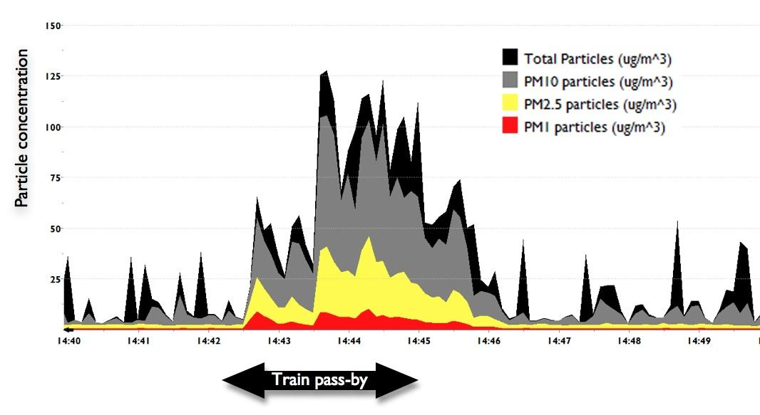

- Signature 2 is indicative of an unloaded coal train pass-by. Unloaded coal trains generally approached the Beresfield CTAG monitor (9m from track) at higher speeds than loaded coal trains. This unloaded coal train (with 3 locomotives and 98 wagons) slowed to an average speed of 35km/hr. The wind was moving at 0.13km/hr and turned from N to the direction of the train, which was SE/SSE during the pass-by.
- This signature shows two initial spikes in particulate matter with a one-minute delay and then a third, larger and more sustained pollution plume. The signature shows a clear indication of diesel emissions (PM1) and strong PM2.5 levels accompanying the high levels of PM10. The two-minute average of PM10 was 66.7ug/m³ compared to the two-minute average pre-train level of 6.6ug/m³. An entrainment of more than four minutes is noted.
- The CTAG study found that 80% of coal trains produced a recognisable pollution signature. The analysis of two-minute segments of these signatures showed that PM10 levels were at least double pre-train particulate levels, and ranged up to 13 times larger. It was not uncommon to have PM10 spikes beyond 100 ug/m³ and PM2.5 spikes between 25 - 50ug/m³ while trains passed the monitor.
- Based on these findings, it is my view that the construction of T4 will cause a critical increase in harmful coal train pollution along the rail corridor through Hunter towns and Newcastle suburbs. Entrainment of carcinogenic diesel exhaust combined with PM10 and PM2.5 creates a toxic pollution source that must be mitigated at the development planning stage, not deferred to a later time and to others who may or may not take responsibility.
(2) In your opinion, in the context of promoting public health, are the assumptions used in determining the air quality impacts of the T4 Project appropriate?

Summary
- In my view, several key assumptions used in calculating air quality predictions at the site are not appropriate, and lead to systematic underestimations of the likely impacts. These include the number of locomotives per full train throughput, the actual amount of time each train remains on site...
Number of locomotives per train, train time on site & staging areas
- In my opinion, T4 site emissions for PM2.5 are significantly underestimated by assuming that only two locomotives are required to pull 7200 tonnes of coal per train movement. CTAG observations of loaded coal trains showed that 76% of trains with 72 wagons or more had three locomotives in the train composition.
- With virtually no NSW diesel locomotives having any PM emission controls (AQ Assessment, Appendix O, pg 73; EPA, June 2014), and producing 1.321 grams of PM10 per litre of diesel combusted (Environ, June 21, 2012, pg. 27), these movements are a major source of carcinogenic fine and ultrafine particulates, as recorded in the CTAG train signature study. (Note: Nearly all diesel exhaust particulates have sizes of significantly less than PM1; https://www.dieselnet.com/tech/dpm_size.php.)
- Furthermore, PWCS gave no evidence to support the assumption that coal trains only spend 2 hours on the site. An interview I had with a coal train locomotive driver employed in the Hunter coal chain for over 20 years indicated that 2 hours is an ideal time for a ‘smooth run.’ In his experience, smooth runs only occur about 40% of the time. Delays occur on the majority of the runs on site, lasting a few minutes to a few hours. These are caused by issues such as stopping to change drivers, other trains moving onto the pathway in front, slow downs at the tipping bin, breakdowns of bin machinery, and so forth.
- Given that the locomotives are run continuously during the process of unloading, it is critical to have accurate time specifications of how long each remains on Kooragang, and the number of delays that occur, adding further hours on site. Adjusting for number of locomotives and length of time on site as described above could significantly increase the estimates for PM2.5 emissions (to 50-60 tonnes per annum versus 38.2 tonnes). (This range was calculated by assuming a further 25% PM2.5 increase because most trains have three locomotive, rather than two, plus 20-30% increase in average time spent on site, i.e. a further 35--45 minutes).
- Furthermore, trains standing by on the tracks between Hexham and Sandgate waiting to enter the coal loading area must also be included in these calculations. These locations should be considered extensions of the T4 operations as they are in daily use as staging areas. The driver reported occasions when he was standing by for hours in these locations because of delays due to problems at the unloading bin, being ahead of schedule, and movement of the stacker/reclaimer.
- In brief, T4 emissions estimates are highly sensitive to these types of assumptions located in the report appendices. Combustion gases and particulate concentrations need to be re-analysed to reflect additional locomotive engagement, additional time spent on site, and the staging time of trains along the tracks outside the entrance to T4. Near doubling of the coal haulage onto Kooragang, when the Port reaches 280Mtpa, will significantly increase occasions for delays as reported by the locomotive driver.

Value of Clean Air
- Access to clean air is essential for supporting life on our planet. Unpolluted air is priceless and worthy of society’s efforts to maintain it. Once air is polluted, it is hard to reverse course. Leading air pollution and health scientist, Arden Pope III, concludes that polluting the cleanest air produces the most harm (i.e., the slope of the dose-effect curve is steepest at the lowest levels of air pollution). The main effort of government should be towards protecting clean air and reducing existing pollution (Pope, September 24, 2013; Pope et al., 2009; WHO, 2013).

Health burden of pollution
- The 2010 Global Burden of Disease (GBD) study found ambient pollution was the cause of 3.2 million deaths globally, causing 76 million years of healthy life lost, and is ranked 9th out of 67 risk factors for disease (Lim et al., 2012). In Australia, over 3000 deaths in 2003 were attributable to urban air pollution; this is 2.3% of all deaths (Begg, et al., 2007). For the lower Hunter, Morgan et al. (2005) suggested a range of 210-473 extra deaths in 2003 from PM10 (above a threshold of 7.5ug/m³). Overall, Morgan et al. estimated particle pollution cost the NSW economy an annual average of $4.7 billion (2000/2001). The NEPC impact statement put the national health costs of air pollution in Australia at between $11.1 billion to $24.3 billion annually, “solely as a result of mortality” (NEPC, 2014, p.13.)
- Very significantly in relation to rail corridor air quality, the 2013 WHO evaluation of evidence on health aspects of pollution reaffirmed the importance of assessing the coarse fraction particle sizes, PM2.5 to PM10, associated with coal dust. This size is strongly linked to respiratory tract disease (e.g., COPD, asthma, respiratory admissions) as well as daily mortality (see Brunekreef & Forsberg, 2005). PM10 has its own unique pathway to disease, beyond that of PM2.5, and should continue to be given weight in air assessment separately from PM2.5. In particular, coal dust is found in the ‘mechanical’ PM10 fraction (less so in the PM2.5 ‘combustion fraction’) (Cambra-Lopeza, et al. 2010), and is emitted into the air through coal train movements, dumping, conveying, and wind erosion from the coal stockpiles (Higginbotham, et al, 2010). WHO (2013) concludes: “Coarse and fine particles deposit at different locations in the respiratory tract, have difference sources and composition and act through partly different biological mechanisms and result in different health outcomes (p8).”
- Adding to evidence of harms from pollution, WHO’s International Agency for Research on Cancer (IARC) recently released a state-of-the-art overview classifying air pollution as ‘carcinogenic to humans’ (IARC, 2013). While “the precise chemical and physical features of ambient air pollution vary around the world… the mixtures of ambient air pollution invariably contain specific chemicals known to be carcinogenic”. In particular, IARC found sufficient evidence that exposure to outdoor air pollution is a cause of lung cancer and estimated 220,000 premature deaths globally from this cause (IARC, 2013).

Hot spots (peak sites)
- Census data show that more than 25,000 residents live in 10 suburbs within 2kms of T4. Geo-mapping of small-scale census collector districts show that 32,000 people reside within 1/2km of the rail corridor between the Port and Rutherford. Neighbourhoods near T4 have a past history of heavy industrial pollution and particulate levels are building again as new industries develop on Kooragang Island and other port sites. Background emission sources include two main arterial roads bordering the T4 site with high levels of commuter and commercial diesel traffic (Industrial Highway/Maitland Rd and Cormorant Rd). These emissions sources are not unlike heavy use roads found in other cities.
- Air science and health research experts testified at the 2013 Senate hearings on coal industry pollution that ‘hot spots’ (such as T4 impacted neighbourhoods) merit localised air quality monitoring and control action. However, NEPM monitors are typically located away from point sources of pollution emissions, to assess background or ‘ambient’ air quality where the population generally resides. (See 2013 Senate Hearings testimony of Prof. Guy Marks, Prof. Wayne Smith, Dr. Steve Hambleton).
- Strengthening the argument to monitor hot spots are findings from the Dust in our Neighbourhoods study (CTAG, March, 2013) indicating for 7 of 11 residences monitored [with Osiris], the PM10 NEPM standard of 50ug/m³ was not met on at least one day during a week long monitoring period.
- The same ‘dose-effect’ chain operates no matter how large or small the human receptor population may be (Briggs, 2003). When the absorbed dose entering the body as a whole is sufficient, then adverse health consequences follow. Small scale communities should not be excluded from surveillance monitoring risk exposure and protection from hazardous sources just because it is difficult to identify excess deaths and disease from low background numbers.

Particulate concentration-response (CR) functions
- The science underpinning the above calls for a new approach to air quality impact assessments for T4, has emerged from epidemiological research on ‘particulate concentration-response functions.’
- Estimates of the relationship between pollution exposure and health outcomes is in the range of 3% to 15% increase in mortality for every 10ug/m³ of annual mean PM2.5 (see Krewski, Table 1, 2009, p. 414 below.) The estimate for all-cause mortality with the best adjustment for confounders is of 6% for every 10ug/m³ increase (Pope, et al., 2002, Table 2, 1136; see more recent studies by Cesaroni, 2013; Yim, 2012; Crouse, 2012).
- Krewski (2009) summarised the American Cancer Society Prevention Study II, a cohort investigation, shown in the table below (Krewski, 2009, p. 414). The American Cancer Society cohort includes more than 1.2 million people followed since 1982. Risk factor data for 500,000 adults were linked with air pollution data and combined with cause of death. For each 10ug/m³ increase in PM2.5 concentrations, deaths from cardiopulmonary disease increase up to 10% and by 15% for ischemic heart disease.

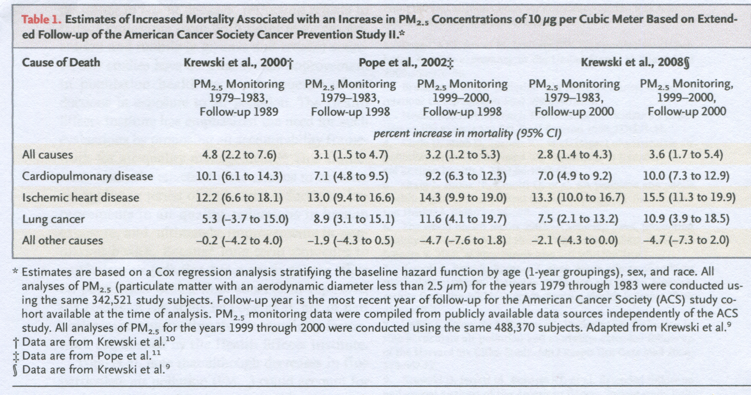

- The photo below of the Kooragang Newcastle Coal Infrastructure Group stacker/reclaimer (October 17, 2013, 11am) indicates that ‘best practice’ techniques to control fugitive coal dust emissions can fail, especially when testing weather conditions occur, such as a strong, dry westerly wind.

Figure 3: Kooragang Island, Newcastle Coal Infrastructure Group,
Thursday, 17 October, 11am.
- 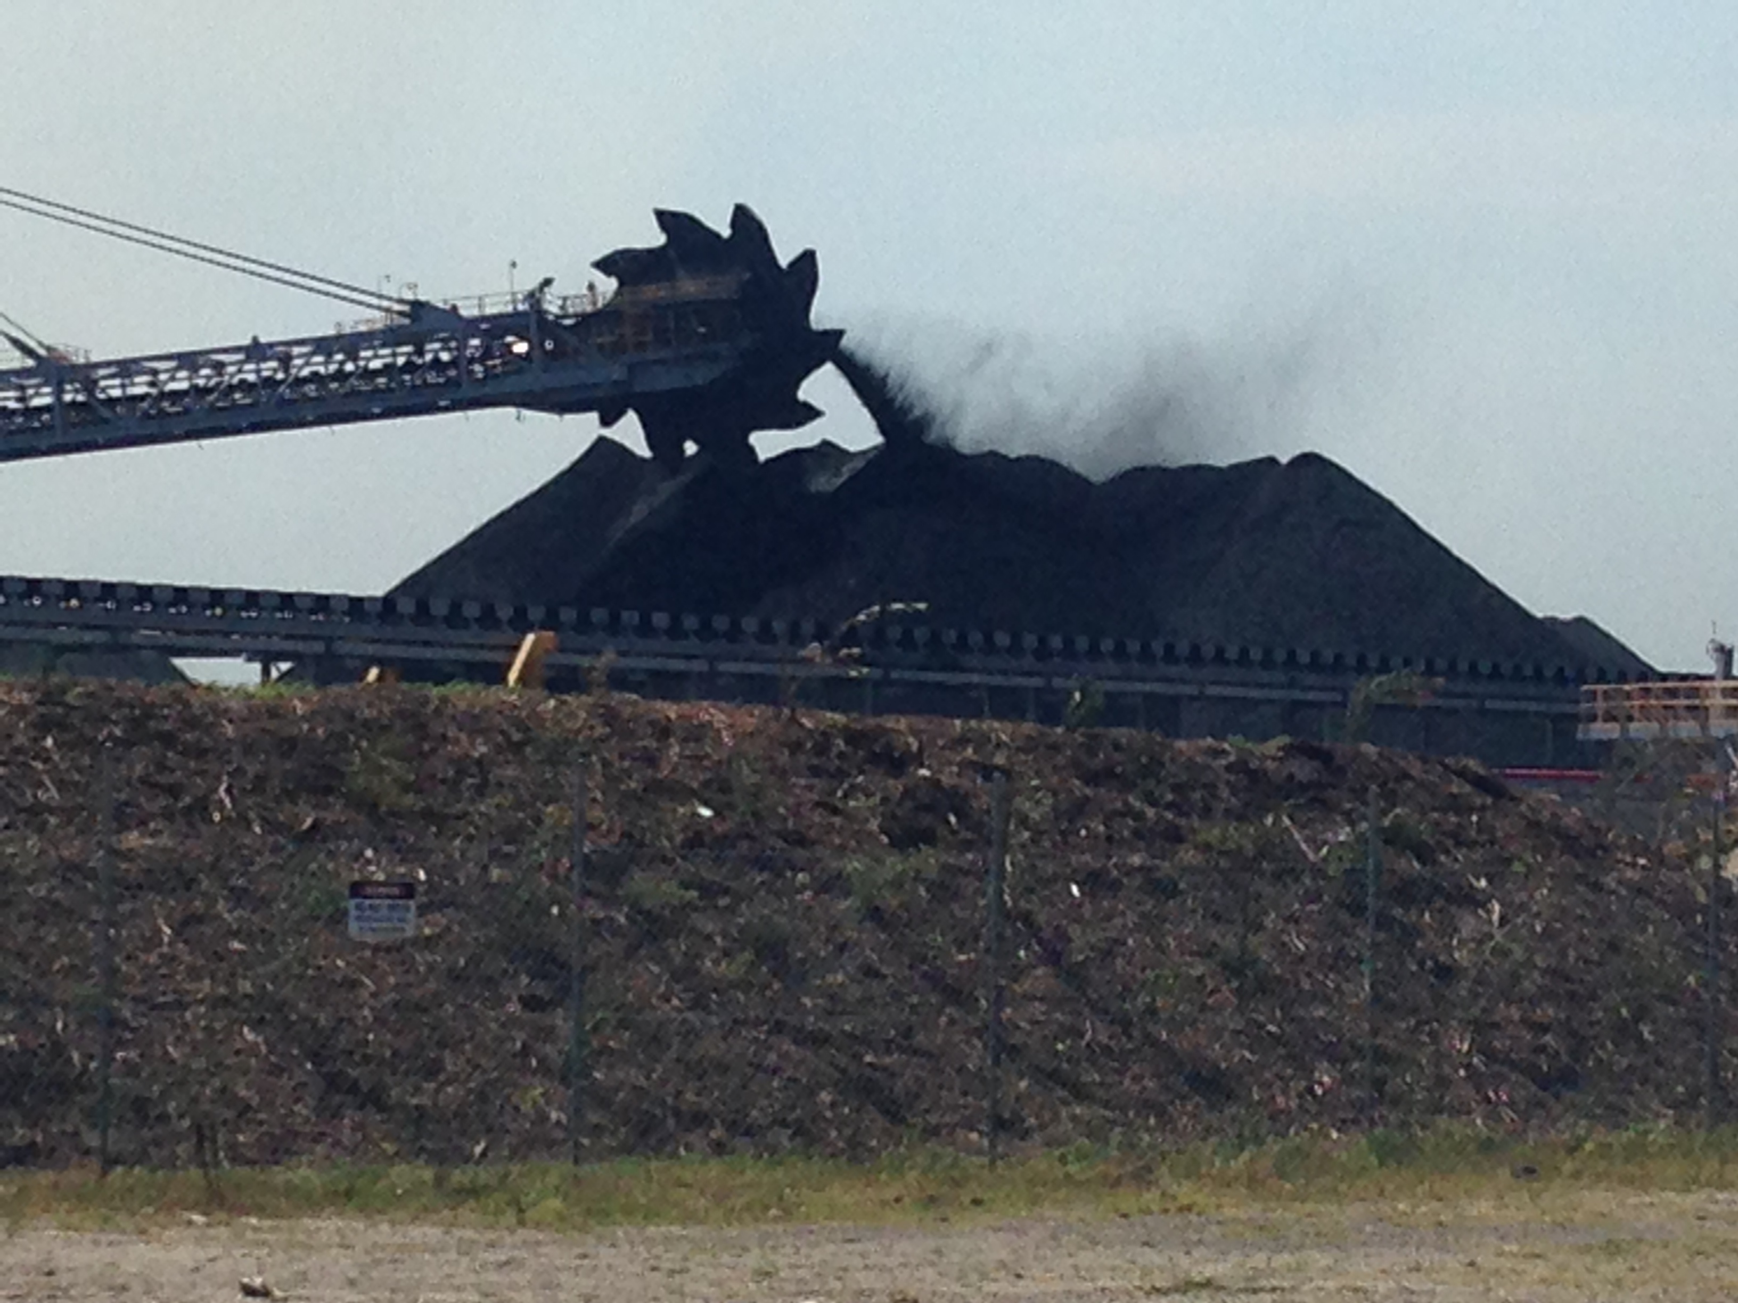

- The dust coming off the stacker is blowing toward Stockton, which had a dramatic PM10 exceedence on the monitor that day (17 October, 2013, shown in the graph below the photo).

- 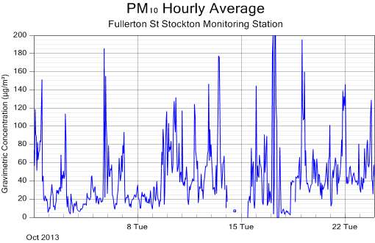

- EPA monitoring showed the 24-hour average PM10 upwind of the Kooragang coal loader on that day at Wallsend was 50.7ug/m³ and downwind at Stockton was 75ug/m³. Clearly, the source of emissions was located between Wallsend and Stockton—i.e., Kooragang Island.

(6) Provide any further observations or opinions which you consider to be relevant from an air quality and public health perspective, having regard to the circumstances of this matter.
Critique of ARTC 2013 Metford Osiris Monitoring Data

- As part of a Pollution Reduction Program (PRP4 & PRP4.2), the EPA required ARTC to fund two studies (2012 & 2013) to determine whether Hunter coal trains and rail transport generally are contributing to ambient particulate levels, and whether loaded coal trains are a larger cause of PM than unloaded coal trains and other trains. However, appraisal of how these studies were designed, analysed and reported to the community suggests, in my view, an unsound and incomplete investigation of rail pollution.

- The ARTC funded studies of coal train pollution merit attention when assessing T4 because: 1) they contain obvious methodological flaws and yet the results of the first study were accepted uncritically by the PWCS consultants as evidence that train emissions are unimportant; 2) the EPA relied upon the second ARTC study to make a decision against requiring train dust mitigation, such as covering loaded coal wagons entering the PWCS loading site.

ARTC Pilot Study (Environ, September 2012)
- Pilot studies can be extremely valuable for testing procedures, instruments and field sites under real life conditions and trialing analytic methods and techniques. Results are normally given little weight, especially when flaws are detected in the pilot methods. Nonetheless, PWCS air quality consultants Environ and Dr David McKenzie (Air Quality Assessment, PPR Appendix D) go into some detail about the pilot results, comparing differences between trains, with no caution about the pilot study’s significant limitations.
- In my opinion, the study’s results are significantly flawed because:
i) The Osiris dust monitors set up on Mayfield and Metford only captured pass-by emissions every one minute (later adjusted to every 30 seconds). Such intervals gave invalid measurements because train types have highly variable pass-by times (between 2 seconds [passenger] and 90--180 seconds [coal and freight]);
ii) The Mayfield monitor had a flawed “train movement system that may have resulted in a misalignment of air quality data to the relevant train movement” (Environ, September, 2012 pg7);
iii) As shown in Figure 1 above, the pollution plume (particulate concentration time series or ‘signature’) of each train pass-by is unique. It may begin some time after the front of the train passes and continue well after it fully passes. The monitor logging intervals were too crude to capture this variability. The study authors choice of a factor of 3 to extend the averaging time during low wind conditions, (see pg 57) would lead to markedly lower average concentration levels.

Second ARTC Study (Katestone, May 2013)
- The Katestone study in Metford in early 2013 improved train emissions measurement by logging particulates every six seconds. However, other problems with instrument failure, unusable data, inappropriate outcome measure, and incorrect statistics (identified in independent review; Knibbs, July, 2013) greatly undermined the study’s interpretations.
- As noted above, Prof Ryan (February, 2014) performed a reanalysis of the Katestone data, and her approach applying regression analysis to the time series data appears appropriate regarding the questions she was asked to answer.
- The task was made harder by missing data from the monitor itself; only 56 of 61 monitoring days could be used (i.e., had at least 1000 measurements), and only 44 such days included wind data.
- She concluded that the passage of freight and coal trains elevated particulates above baseline levels by about 10% and this is highly statistically significant.

Design flaw
- In my view, the study has a fundamental design flaw in that only one trackside monitor was deployed. This introduced the strong likelihood of systematic measurement error (bias): different tracks are different distances from the monitor. Of the four train tracks, the closest is about 3.7m mid-rail from the monitor, and the furthest 13.7m mid-rail from the monitor.
- The bias is introduced by the normal operation of different types of trains. Passenger and freight trains use the two ‘main line’ tracks closest to the monitor. Coal trains use the two coal lines tracks furthest from the monitor. An unloaded coal train (normally on the furthest track) is more than three times the distance away from the monitor as a freight train (or passenger train) on the first main line.
- This issue is not mentioned in Prof Ryan’s 2014 & 2015 reanalyses, although it was listed as a ‘limitation’ in the Katestone report (2013, pg viii). The implications of this measurement bias are not trivial, given the potential dispersion and lowering of particulate concentrations as they move away from their source.
- Moreover, the EPA has used freight train emissions as a standard against which to judge whether mitigation of coal train dust should take place. With the report indicating there are no differences in particulate levels comparing coal and freight trains, the authority decided against introducing mitigation measures to reduce any train emissions.

Wind direction
- The other problem with deploying only one monitor is wind direction. Wind blowing from behind the monitor may blow train emissions away from the monitor, recording a diminished reading of what a passing train is actually emitting. Given that coal trains are the furthest from the monitor, their emission levels may be the most underestimated.
- Professor Ryan in fact notes that magnitude of dust effects increased when the wind direction was toward the monitor and dampened and some effects lost significance when wind blew away from monitor. However, none of her 2014 modeling examined wind direction as an effect modifier: To what extent is the increase in train pollution measured by the monitor (the effect) influenced by wind direction?
- The 2014 report gave only one statistic in relation to the wind direction effect, noted above. TSP levels when no trains were passing rose from 26.28ug/m³ to 33.41ug/m³; an increase of 27% when wind is blowing toward the monitor.
- Professor Ryan’s 2015 analysis again stated that “having the wind blowing towards the monitor is an important predictor of particulate levels (p.16).” But, wind as an effect modifier was not looked at. What is required is running the analysis when wind is blowing towards the monitor, running a second analysis when it is not blowing toward the monitor, and then comparing the two models.
- If wind direction is a significant effect, then the magnitude of pollution should be reported and discussed in the condition when it is blowing towards the monitor. In the Appendices, Prof Ryan did include a regression term (variable) in several models that indicates whether or not wind was blowing towards the monitor. While including this variable in the model does not test whether wind direction is an effect modifier, it does show that it is a statistically significant predictor in all but one model. When “WindToward” is included, the variables “Freight Passing” (the 5 minute period after a freight train passes) and “Rain” (in Maitland the previous day) are no longer statistically significant. In contrast, all coal train emissions continue to show significant increases. The interpretation of these findings is not discussed.
- In sum, Prof. Ryan’s 2015 results raise more questions than they answer. Given the underlying major flaws in the ARTC data set, and the failure to separate the data according to wind direction, little can be said about these results other than train movements were associated with increased pollution.

Total exposure profile
- Nevertheless, it is significant to note that Prof Ryan (2014) suggested more work could usefully be done to determine a way to measure the total particulate exposure profile associated with train passings. It is essential in emissions assessment, in my view, to determine the total volume of particulates, not just the average level, during a pass-by.
- Total volume includes the length of time multiplied by the (average) particulate concentration levels during that pass-by. This is the ‘area under the curve’ in the particulate profile of a pass-by; it is the cumulative effect of emissions, including after the train has passed, when particulate levels remain elevated above baseline (see CTAG, August, 2013).
- Assessing total volume of particulates more meaningfully allows comparison between train types than a simple average. A two second pass-by of a passenger train and a 103 second pass-by of a loaded coal train can have the same average elevation (or average increase), but the volume or aggregate exposure differs considerably.

Example of total exposure measurement
- Using Prof Ryan’s 2014 Table 2 and Table 3 values, colleagues and I have calculated a rough estimate of this total exposure (on average) for different trains for PM10. For Unloaded coal trains, Freight and Loaded coal trains we:
- Multiplied the ‘No Train’ baseline rate (22.78ug/m³) times the relevant (exp)*coefficients. This gave us adjusted per second averages for each train type. We then subtracted this adjusted average from the baseline to get the average increase in particulates per second.
- Train type average increases for PM10 were: 2.12ug/m³ Coal Unloaded; 2.07ug/m³ Freight; and, 1.77ug/m³ Coal Loaded.
- These values were multiplied by the average duration of pass-by for each train type shown in Table 1 (72, 69 and 103 seconds respectively for Unloaded Coal, Freight and Loaded Coal trains).
- We found: compared with a Freight Train, that Unloaded Coal trains produce 7% more total volume of particulates, and Loaded Coal trains produce 28% more per pass-by.

Further development of this new measure
- Professor Ryan states that this new measure could be achieved by combining physical concepts, such as aerodynamics, as well as applying more sophisticated statistical modeling techniques to empirically capture and model the profiles. The CTAG train signature study offers a forensic look at the phenomenon to be captured, and bringing together these two levels of understanding total exposure could prove highly informative for regulators, industry and the public.
This could be a fruitful topic for the NSW Chief Scientist to pursue in relation to the review of rail coal dust emissions management practices.

References

American Heart Association (AHA). (June, 2010). Particulate matter air pollution and cardiovascular disease: An update to the scientific statement from the AHA. Circulation. 121, 2331-2378. (R.D. Brook, et al.).

Barnett, A. (in press). It’s safe to say there’s no safe level of air pollution. Australian & New Zealand Journal of Public Health. Accepted May 2014.

The Australian Academy of Technological Sciences and Engineering (ATSE) (2009). The hidden costs of electricity: Externalities of power generation in Australia. ATSE, Parkville, VIC: Ian McLennan House.

Begg S, Vos T, Barker B, Stevenson C, Stanley L, Lopez A. The burden of disease and injury in Australia 2003. AIHW cat. no. PHE 82. Canberra: Australian Institute of Health and Welfare, 2007, accessed 12 February 2014, www.aihw.gov.au/bod/index.cfm

Blackmore, K.L. & Goodwin, I.D. (2008). Report 2: Climate variability o f the Hunter, Lower North Coast and Central Coast Region o f NSW. A report prepared for the Hunter and Central Coast Regional Environmental Management Strategy, NSW.

Blackmore, K.L. & Goodwin, I.D. (2009). Report 3: Climatic change impact for the Hunter, Lower North Coast and Central Coast Region o f NSW. A report prepared for the Hunter and Central Coast Regional Environmental Management Strategy, NSW.

Briggs, D. (2003). Environmental pollution and the global burden of disease. British Medical Journal. 68, 1, 1-24.

Brunekreef, B. & Forsberg, B. (2005). Epidemiological evidence of effects of coarse airborne particles on health. European Respiratory Journal, 26, 309-318.

Burnett, R.T., Cakmak, S., Brook, J.R., Krewski, D. (1997). The role of particulate size and chemistry in the association between summertime ambient air pollution and hospitalization for cardiorespiratory diseases. Environmental Health Perspective, 105, 614–620.

Cambra-Lopeza, M. (2010). Airborne particulate matter from livestock production systems: A review of an air pollution problem. Environmental Pollution, 158(1), 1-17.

Cesaroni, G., et al (2013). "Long-Term Exposure to Urban Air Pollution and Mortality in a Cohort of More than a Million Adults in Rome." Environmental Health Perspectives 121(3): 324-331.
COAG, Standing Council on Environment and Water (SCEW). 2013. http://www.scew.gov.au/nepms/ambient-air-quality accessed 18/10/13).

Connell Hatch (2008). Environmental evaluation on fugitive coal dust emissions from coal trains: Goonyella, Blackwater and Moura Coal Rail Systems, Final report, Project undertaken on behalf of Queensland Rail Limited, 31 March, 2008.

Craig, Keith. (personal communication February, 2013) based on review of http://www.stocktonairqualitymonitoring.com

Crouse, D. L., et al (2012). "Risk of nonaccidental and cardiovascular mortality in relation to long-term exposure to low concentrations of fine particulate matter: a Canadian national-level cohort study." Environ Health Perspect 120(5): 708-714.
CSIRO (2007), “Analysis of Carry-Back at the RG Tanna Coal Terminal (Draft), Exploration & Mining Report P2007/893.

CTAG. (March, 2013). Coal dust in our suburbs: A community-led study of particulate pollution in Newcastle and Lower Hunter rail corridor. Coal Terminal Action Group, Dust and Health Committee. Hunter Community Environment Centre, Parry St, Newcastle, NSW.

CTAG (August, 2013). Coal train pollution signature study. Coal Terminal Action Group, Dust and Health Committee. Hunter Community Environment Centre, Parry St, Newcastle, NSW.

Environ (June 21, 2012). Locomotive Emissions Project: Potential Measures to Reduce Emissions from New and In- service Locomotives in NSW and Australia Industry Presentation, ENVIRON North Sydney Offices.

Environ (September, 2012). Pollution Reduction Program (PRP)4—Particulate Emissions from Coal Trains, Report compiled by ENVIRON Australiat Pty Ltd on behalf of the Australian Rail Track Corporation.

Environ (March 2013). PWCS Terminal 4 Project – Air quality assessment for modified project. Appendix O.

http://www.environment.gov.au/soe/2011/report/atmosphere/3-1-current-state-atmosphere.html

http://www.environment.nsw.gov.au/resources/air/ammodelling05361.pdf

European Commission, Environment. http://ec.europa.eu/environment/air/quality/standards.htm
(accessed 22 February, 2013).

Ferreira, A.D., et al (2003). Full-scale measurements for evaluation of coal dust release from train wagons with two different shelter covers. Journal of Wind Engineering and Industrial Aerodynamics. 91, 1271-1283.

Ferreira, A.D & Vaz, P.A. (2004). Wind tunnel study of coal dust release from train wagons. Journal of Wind Engineering and Industrial Aerodynamics. 92, 565–577.

Harris, P. & Harris-Roxas, B. (2010). Assessment of human health and wellbeing in project environmental assessment. In Project environmental clearance: Engineering and management aspects. Wide Publishing, 357-379.

Hibberd, M et al. (2013). Upper Hunter Valley Particle Characterization Study. CSIRO Marine & Atmospheric Research, Australia.
International Agency for Research on Cancer (IARC, 2013). Air pollution and cancer. IARC Scientific Publication No. 161. WHO, Geneva.

Higginbotham, et al. (2010). Environmental injustice and air pollution in coal affected communities, Hunter Valley, Australia. Health and Place, 16(2), 259-266.

Johnston F.H, Webby R.J., Pilotto L.S., et al (2006).Vegetation fires, particulate air pollution and asthma: a panel study in the Australian monsoon tropics. International Journal of Environmental Health Research. 16(6), 391-404.

Katestone Environmental (May, 2013). Pollution reduction program 4.2 particulate emissions from coal trains. Prepared for Australian Rail Track Corporation. Milton, Queensland.

Knibbs, L. (July 2013). Peer review of Australian Rail Track Corporation (ARTC) Pollution Reduction Program (PRP) 4.2 - Particulate Emissions from Coal Trains. http://www.epa.nsw.gov.au/resources/air/ARTC_report_review_Jul_01_2013.pdf

Knibbs, L., deDear, R., Mengersen, K., & Morawska, L. (2009). On-road ultrafine particle concentration in the M5 East road tunnel, Sydney, Australia. Atmospheric Environment. 43, 3510-3519.

Krewski, D., Jerrett, M., Burnett, R.T., et al (2009). Extended follow-up and spatial analysis of the American Cancer Society study linking particulate air pollution and mortality. Health Effects Institute Research Report 140.

Krewski, D. (2009). Evaluating the effects of ambient air pollution on life expectancy. New England Journal of Medicine, 360, January 22, 413-415.

Lim, S.S. et al (2012). A comparative risk assessment of burden of disease and injury attributable to 67 risk factors and risk factor clusters in 21 regions, 1990—2010: a systematic analysis for the Global Burden of Disease Study 2010. The Lancet, 380, 9859, 2224 – 2260.

McCreanor, J. et al. (2007). Respiratory effects of exposure to diesel traffic in persons with asthma. New England Journal of Medicine. 357, 2348-58.

Marks, G. (September 23, 2013). How to investigate the relationship between air pollution and health. Lecture presented at the Air Pollution and Health Symposium, Newcastle City Hall, Newcastle, NSW.

Mills, N., Tornqvist, H., &Gonzalez, M. (2007). Ischemic and thrombotic effects of dilute diesel-exhaust inhalation in men with coronary heart disease. New England Journal of Medicine. 357 (11), 1075-82.

Morawska, L. (2010). Airborne particles and health. Air quality and climate change. 44 (2), 13-15.

Morgan, et al. (2005). Air pollution economics. Health costs of air pollution in the greater Sydney metropolitan region. NSW Department of Environment and Conservation.

Muller, N.Z., Mendelsohn, R., & Nordhaus, W. (August, 2011). Environmental Accounting for Pollution in the United States Economy. American Economic Review. 101, 1649–1675.

National Environment Protection Council (May, 2011). National Environment Protection (Ambient Air Quality) Measure Review
http://www.scew.gov.au/system/files/resources/3405e986-afe9-bdb4-5d2c-383f3ea1e911/files/aaq-review-report-2011.pdf

National Environment Protection Council (July, 2014). Draft variation to the National Environment Protection (Ambient Air Quality) Measure: Impact Statement. http://www.environment.gov.au/protection/nepc/nepms/ambient-air-quality/variation-2014/impact-statement

NSW Environment Protection Authority (June 2014). Diesel emissions and their management in NSW. Background paper for EPA diesel emissions workshop. http://www.epa.nsw.gov.au/resources/air/140426diesbgdpaper.pdf

NSW Department of Health, Environmental Health Branch. 2010 review of hospital separation etc Respiratory and cardiovascular diseases and cancer among residents in the Hunter New England Area Health Service. May 2010
http://www.health.nsw.gov.au/pubs/2010/hne_respi_cardio.html

Pope, A. (September 24, 2013). Particulate matter air pollution: science, controversy and impact on public health. Lecture presented at the Air Pollution and Health Symposium, Newcastle City Hall, Newcastle, NSW

Pope CA 3rd, Burnett RT, Thun MJ, Calle EE, Krewski D, Ito K, (2002)
Lung cancer, cardiopulmonary mortality, and long-term exposure to fine particulate air pollution. JAMA, 6;287(9):1132-41.

Pope, C.A. & Dockery, D.W. (2006). Health effects of fine particulate air pollution: Lines that connect. Journal of Air and Waste Management Association. 56, 709-742.

Pope, A., Ezzati, M., Dockery, D.W. (2009). Fine-particle air pollution and life expectancy in the United States. New England Journal of Medicine, 360, 4, 376-386.

Power, S., et al. (2013). Robust twenty-first-century projections of El Niño and related precipitation variability. Nature, October 13, published online. doi:10.1038/nature12580

Rushton, L. (2012). The problem with diesel. Journal of National Cancer Institute. 104 (11), 1-2.

Rushton, L., Bagga, S., & Bevan, R., et al. (2010). Occupation and cancer in Britain. British Journal of Cancer. 102(9), 1428–1437.

Ryan, L., Wand, M. (February, 2014) Re-analysis of ARTC Data on
Particulate Emissions from Coal Trains. http://www.epa.nsw.gov.au/resources/air/ARTCreanalysisFeb2014.pdf

Ryan, L., Malecki, A. (2015). Additional analysis of ARTC Data on Particulate Emissions in the Rail Corridor.
http://www.epa.nsw.gov.au/resources/air/artc-dust-ryan-report.pdf

Senate, Commonwealth of Australia, Community Affairs References Committee, Impacts on health of air quality in Australia. Hearing Testimony, Tuesday, 16 April, 2013, Newcastle.

Silverman, D.T., et al. (2012). The diesel exhaust in miners study: A nested case-control study of lung cancer and diesel exhaust. Journal of the National Cancer Institute. 104(11): 855–868. http://www.ncbi.nlm.nih.gov/pmc/articles/PMC3369553/

Transport for NSW, Media Release, 10 January, 2014.
http://www.transport.nsw.gov.au/media-releases/newcastle-continues-set-record-coal-exports (accessed 22 February, 2013).

Weinmayr, G., et al. (2010). Short-term effects of PM10 and NO2 on respiratory health among children with asthma or asthma-like symptoms: A systematic review and meta-analysis. Environmental Health Perspectives. 118(4), 449-457.

WHO (2006). Air Quality Guidelines Global Update 2005: Particulate matter, ozone, nitrogen dioxide and sulphur dioxide. World Health Organisation Regional Office for Europe, Copenhagen, Denmark.

WHO-Europe (2013). Review of evidence on health aspects of air pollution—REVIHAPP Project, First Results. Copenhagen, Denmark: WHO Regional Office for Europe.

Yim, S. H. L., Barrett, S.R.H (2012). "Public Health impacts of combustion emissions in the United Kingdom." Environmental Science and Technology, 46 (8): 4291-4296.

