Chief Scientist’s team visit of the 12th January 2016
9:30 am start at McDonalds Mayfield East

Present
Chief Scientist’s team
Carrie Waring
Jaclyn Aldenhoven
Justin Walker
Chris Armstrong
Correct Planning and Consultation for Mayfield’s team
John Hayes
Rick Banyard

The sites visited and the issues raised included but were not limited to:-

Meeting point
- Tabling of documents and history of CPCFM complaint.
- The ARTC TOC (operations manual)now includes documents that coal wagons have a maximum load height equal to wagon sill height. Therefore if you can see coal in a wagon then it is overloaded and in breach of the EPL.
- Safety induction to activity

Carrington rail yards (Morandoo)
- Visual of the northern side of the Carrington Coal Terminal
- Discussion about washing trains as they move out of the unloading station.
- The potential use of existing gantries to mount water jets.
- Average age of locos for coal haulage is a fraction of the total loco fleet age (about 35 years). Clean newly painted locos seen in the yard may be very old and are often used for shunting only.

Question on Notice. How old are the coal locos?
Answer
Chart prepared by Rick Banyard 24/3/2014 and updated 28/3/2014
Class | operator | Number Made | Hunter Locos on Coal duty | Date entered service | Power
81 | Pacific National | 84 (1 stored) | 0 | 1982 – 1991 | 2460kw
82 | Pacific National | 52 | 10? | 1994 – 1995 | 2425kw
90 | Pacific National | 35 | 35 | 1995 – 2005 | 3030kw
92 |  | 128 |  | 2008 - | 3370kw
 | Pacific National |  | 15 | 2008
 | QR (QN6000) |  | 10 | 2008
 | Xstrata |  | 30 | 2008 -
 | CFL |  | 12 | 2009 -2013
 | SSR |  | 5 | 2012
TT | Pacific National | 37 | 37 | 2009 – 2012 | 3350kw
WH (like TT) | White Haven | 3 | 3 | 2009 | 3350kw
QN 5000 | QR | 12 | 12 | 2005 – 7
QN 5020 | QR | 19 | 19 | 2010 – 2011
BRN | SSR/ | 2 | 2? | 2013 | 2460kw
 |  | Total | 190
Information Sources
http://en.wikipedia.org/wiki/QR_National
http://en.wikipedia.org/wiki/Pacific_National
http://www.flickr.com/groups/2214502@N25/
http://www.23hq.com/navarzo4/photo/7371181
http://www.23hq.com/navarzo4/loco
http://www.qrig.org/motive-power/locomotives/diesel/qrnational/ugl-railge-5000-class
http://en.wikipedia.org/wiki/New_South_Wales_81_class_locomotive
http://en.wikipedia.org/wiki/New_South_Wales_82_class_locomotive
http://en.wikipedia.org/wiki/New_South_Wales_90_class_locomotive
http://en.wikipedia.org/wiki/New_South_Wales_92_class_locomotive
http://en.wikipedia.org/wiki/QR_National_5000_class
http://en.wikipedia.org/wiki/QR_National_5020_class
http://en.wikipedia.org/wiki/Downer_EDI_Rail_GT46C_ACe#TT_class (TT class)
http://www.bing.com/images/search?q=southern+shorthaul+railroad&qs=AS&form=QBIR&pq=southern+shorthaul&sc=5-18&sp=1&sk=
http://www.railpage.com.au/locos/browse/operator/14/
Plus numerous other sources including Ricks records, notes and photos.

Question on notice: How much water would it take to wash a coal wagon?
Answer
CPCFM believes that car washing research may help provide and answer.
( http://www.carwash.org/docs/default-document-library/water-use-in-the-professional-car-wash-industry.pdf)
High pressure nozzles fitted on frame would direct water (sourced from the stockpile sprays) to flush the train internally and externally immediately after unloading as the train moves slowly through the unloading station. A 15 metre wagon would take about 20 seconds to pass through giving a water use of about 100 litres with a loss of less than 2%. Water consumption would for an 80 wagon train be:-
100 X 80 = 8,000 litres
98% recovery = 7840 litres
Water used per train = 160 litres
The only water lost would be from evaporation and carry out.
Used water would be returned to the stockpile sprays. Coal sediment would be returned to the inbound coal elevator.

A recent observation showed a quick downpour effectively cleaned a very dirty wagon.

Coal | Train | Speed
 |  |  | Length of Wagons per train
 | Speed kph | metres/second | 850 | 1250 | 1543
 |  |  | Seconds for passby
 | 5 | 1.39 | 612 | 900 | 1111
 | 10 | 2.78 | 306 | 450 | 555
 | 15 | 4.17 | 204 | 300 | 370
 | 20 | 5.56 | 153 | 225 | 278
 | 25 | 6.94 | 122 | 180 | 222
 | 30 | 8.33 | 102 | 150 | 185
 | 35 | 9.72 | 87 | 129 | 159
 | 40 | 11.11 | 77 | 113 | 139
 | 45 | 12.50 | 68 | 100 | 123
 | 50 | 13.89 | 61 | 90 | 111
 | 55 | 15.28 | 56 | 82 | 101
 | 60 | 16.67 | 51 | 75 | 93

Carrington Service centre

- Passed by Service Centre. Used for refuelling, minor repairs and service and driver changes.

Carrington shunting yards (Bullock Island)

- Viewed trains in the yard from the overhead footbridge.
- Most coal wagons showed coal in the wagons and considerable volumes on the platforms
- Numerous coal wagon doors were not sealing.
- A large coal spill was on the track
- Particulates present on freight wagons
- Discussed dirty grain trains and why the lids do not contain particles
- Grain wagon with missing lids
- Question about grain trains issues and escape of grain was partly answered on site but it was agreed to provide a CPCFM information sheet. This is attached to the end of these notes
- Wagon numbering and service identification tags
- Discussed why Hunter coal transport can not be compared with Queensland or other parts of the World. Noted that Powder Valley coal can be as fine as bulldust whereas most coal in the Hunter is washed and crushed at or near mine sites in CHPP’s (Coal Handling and Preparation Plant) before being stored in the stockpile prior to loading.
- Coal dust is only one of the components of rail corridor particulates. Particle characterisation studies will probably show that coal is about 10% however coal is certainly one very major health hazard.
- The method used by CPCFM to quantify the quantities of carry back coal (300kg) and coal lost from loaded wagons(3kg) were explained.

Coal wagon repair and service areas
- Noted heavy repair workshop operation
- Collected coal samples

Selwyn St and Maitland Road rail overpass
- Discussed proximity of households to the track and structures (eg fencing etc) to help enclose the track
- Minerals wagons viewed, Lids needed or the long journey from Cobar of the very fine material
- Viewed drains and discussed coal movement into the watercourses and aquifers
- Discussed the water course and Hunter catchment and how all the Hunter water ends up in Newcastle harbour
- Identified “black tracks” used by unloaded coal trains and noted the large volume of coal on the track that had fallen on from empty wagons
- Coal loss much greater from empty wagons due to residue in the wagons drying out, greater surface area, higher speed and greater vibration
- A single loco was observed passing under the bridge. The exhaust discharge vents were noted as was the black fuel staining of the loco roof
- Automation of monitoring equipment was discussed with emphasis on automatic load height sensors and exhaust gas analysers and the potential to link to smart phones, data loggers etc wirelessly. Potential for automatic fines

ARTC monitor site near Chin Chen St
- Noted the heavy height fence, slow train speed and rail junction
- Commented on why this was a very poor location in which to monitor trains for particulates

Clyde St Crossing
- Noted the impact on the traffic flow of the major level crossing that carries long coal trains
- Noted Hunter Line is not electrified
- Questioned Rick about his 35 years of mining and coal train association in the Hunter Valley and elsewhere
- Discussed the motive power of various train types. All coal trains in NSW are hauled by diesel electric locos
- Viewed a 2 car diesel hydraulic Hunter passenger train

Ctag monitor site at Waratah
- Noted the fences in Upfold St and closeness of houses
- Discussed the location of the monitor noting the raised level where trains travel at reasonable speed using low to mid range power thus minimising the diesel fumes in the air sample.

Broadmeadow rail yards
- Noted the large train holding yard in the middle of populated areas
- Noted westerly winds blow over empty trains
- It is recognised that 500 metres from the track is likely to be heavily impacted by corridor particles
- Particles can carry as far as 2kms from the corridor
- John is dong like many people and painting his house “coal grey”’ so the coal dust is less visible

Adamstown station
- The rail line is electrified
- Coal trains are still diesel
- Commonly four locos to cope with the climb from the Hawkesbury River to Hornsby
- Trains passing at speed makes standing on the platform very uncomfortable due to noise, dust and flying debris
- Adamstown station makes one realise the complexity of rail corridor particulates
- Lumps of coal were observed in the track
- Adamstown rail crossing is a major traffic barrier
- Coal trains travel from the Hunter to Port Kembla
- Both loaded and unloaded coal trains transporting coal from Southern Newcastle mines to the Central coast power stations at Vales Point and Eraring have to travel to the loop at Carrington to turn around.

Kooragang rail entry line
- A unloaded coal train was stopped nearby waiting for headway from a coal train passing the junction on the main line,
- The length of the 80 wagon train was observed stretching about 1250 metres into the distance
- On moving off there was considerable exhaust emissions
- The outbound unloaded train as predicted by Rick was very dirty with wet sticky coal on the sills and inside the wagon, there was considerable internal carry back coal, door gaps and a considerable volume of platform coal

At this point the Chief Scientists party departed for Mount Owen to view the loading of wagons.
It was agreed that Rick and John would continue and would take photos and make notes.

- An inbound loaded coal train passed the outbound empty coal train. It was poorly loaded, the coal was wet and there was considerable platform coal

Sandgate station
- Due to times the Xpt / Explorer were not observed
11.45 Broadmeadow to Maitland 12:15
12:53 Maitland to Broadmeadow 13:19
13:55 Maitland to Broadmeadow 14:19
- No Hunter passenger trains observed

Hexham area
- Rick and John had lunch at the Hexham Bowling Club and from the window viewed about 20 trains pass by during the hour.
- The truck height light beam on the Pacific Highway just north of the Hexham Bridge was observed. The effectiveness and simplicity was obvious.
Taro
- Several coal trains observed from the car

Beresfield CTag monitor location.
- The location in the car park near the station was inspected
- Passing trains observed
- Track layout observed with the coal tracks closest to the monitor
- The area was open and exposed giving minimal interference to monitor readings. Located on the SE side of the tracks

Thornton
- The bund walls and solid fencing were noted as structures to reduce the impacts of the houses along the line. (An outcome of a court action)

Metford Monitor

- The location was inspected and noted to be surrounded with tall trees that would interfere with local breezes
- The undulating terrain was likely to interfere with air drainage and monitor readings.
- The weather details and images were considered that raised serious questions with Prof Ryan’s second study
- Passing trains observed with two coal trains passing at the one time at speed
- Track layout of four tracks of uneven height was observed
- It was noted that the track was straight however undulating
An open drain from the rail corridor flowed through the fence spilling into the adjoining cemetery.
- Test instrument including wheel analysis and a weather station were noted and photographed

The emphasis of the day was on:-
- Trying to observe coal wagons and coal wagon movements
- The community impacts and proximity to residents to the coal corridor
- Monitor locations
- Rail track infrastructure and track layout
- Wagons, consists and locos in service
What we finally observed was heavily impacted by the train movements on the day and the weather

As predicted we did not have any spare time. Additional time would have permitted additional observations

There were plenty of photo opportunities. Rick photographed many of the issues observed

These notes and accompanying photographic record were prepared by Rick Banyard and confirmed by John Hayes on the 13 1 2016.

Train calculator details showing the section about wagon and loco numbers based on the green inputs.

Coal Train and Ship Calculator
 | Number of wagons |  |  | 80
 | Wagon tonnage |  |  | 90
 | Coal Quantity per year |  |  | 160 | Mtpa
 | Capacity per train |  |  | 7200 | Tonnes
 | Trains per year
 |  | loaded |  | 22222
 |  | empty |  | 22222
 |  | total |  | 44444
 | Trains per Day
 |  | loaded |  | 61
 |  | empty |  | 61
 |  | total |  | 122
 | Wagons per day |  |  | 9,741
 | Wagons per year |  |  | 3,555,556
 | Ship movements
 |  | per year |  | 4000
 |  | per day |  | 22

Grain Train Brochure by CPCFM October 2015
Grain trains operate in the Hunter and carry bulk grain to the export terminals in the Hunter. The wagons are about 50 to 100 tonne in capacity, are self unloading and are fitted with lids.
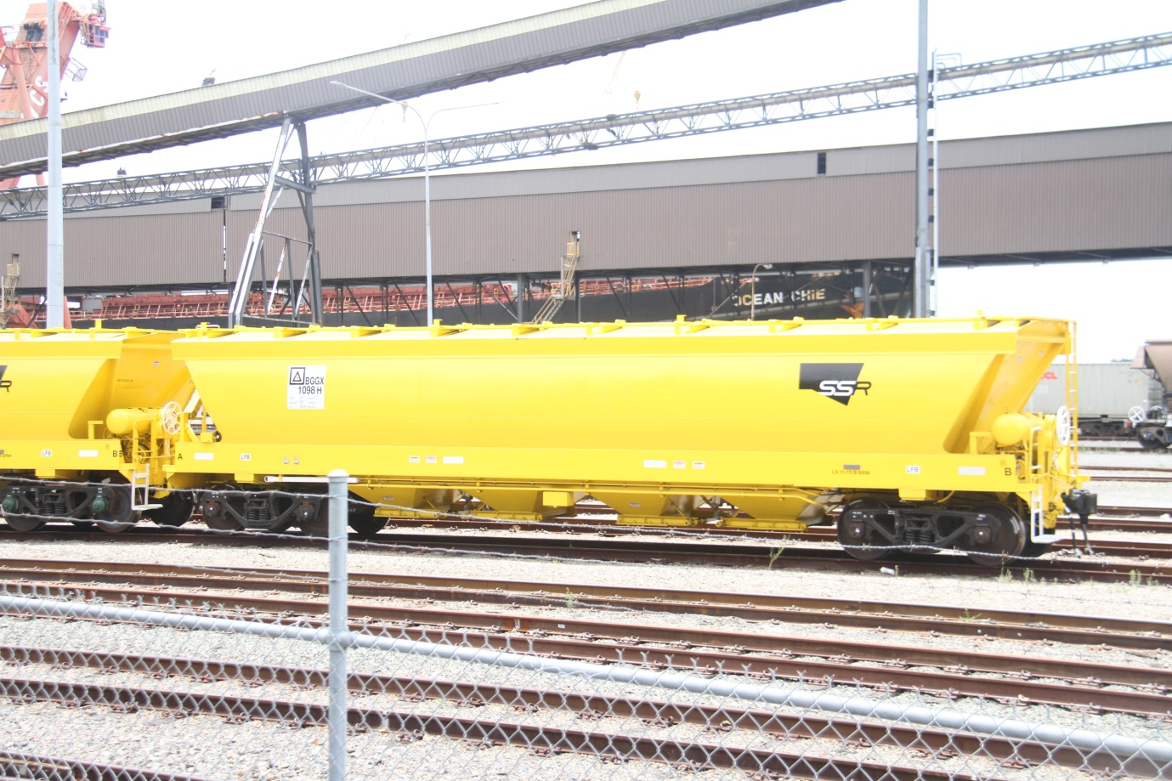
Grain Wagon BGGX 1098H operated by SSR Gross 55 tonnes Net 21 tonnes.
The grain wagons are not sealed and just like coal wagons carry plenty of parasitic grain and other foreign materials.
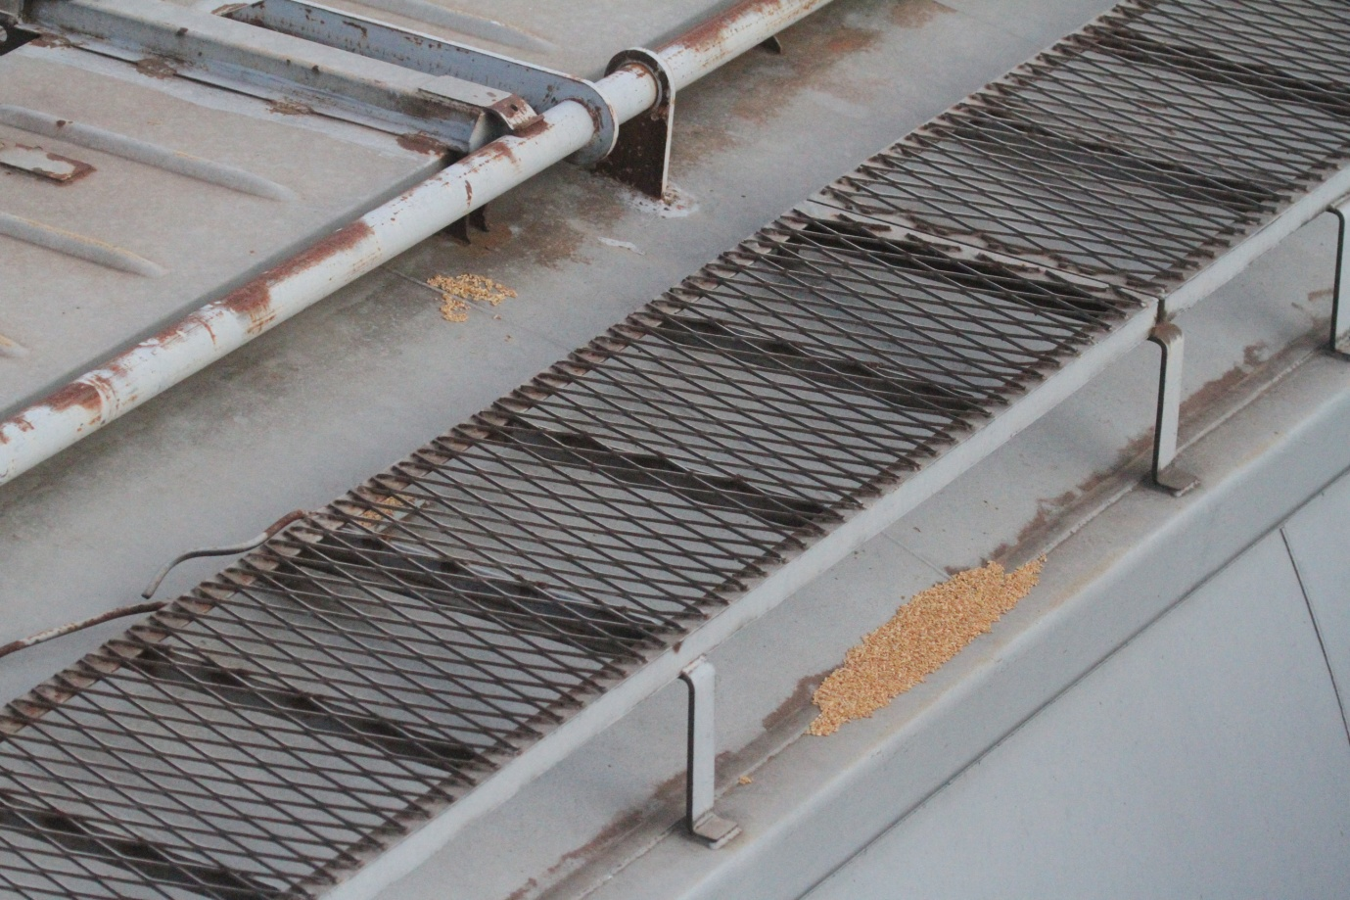

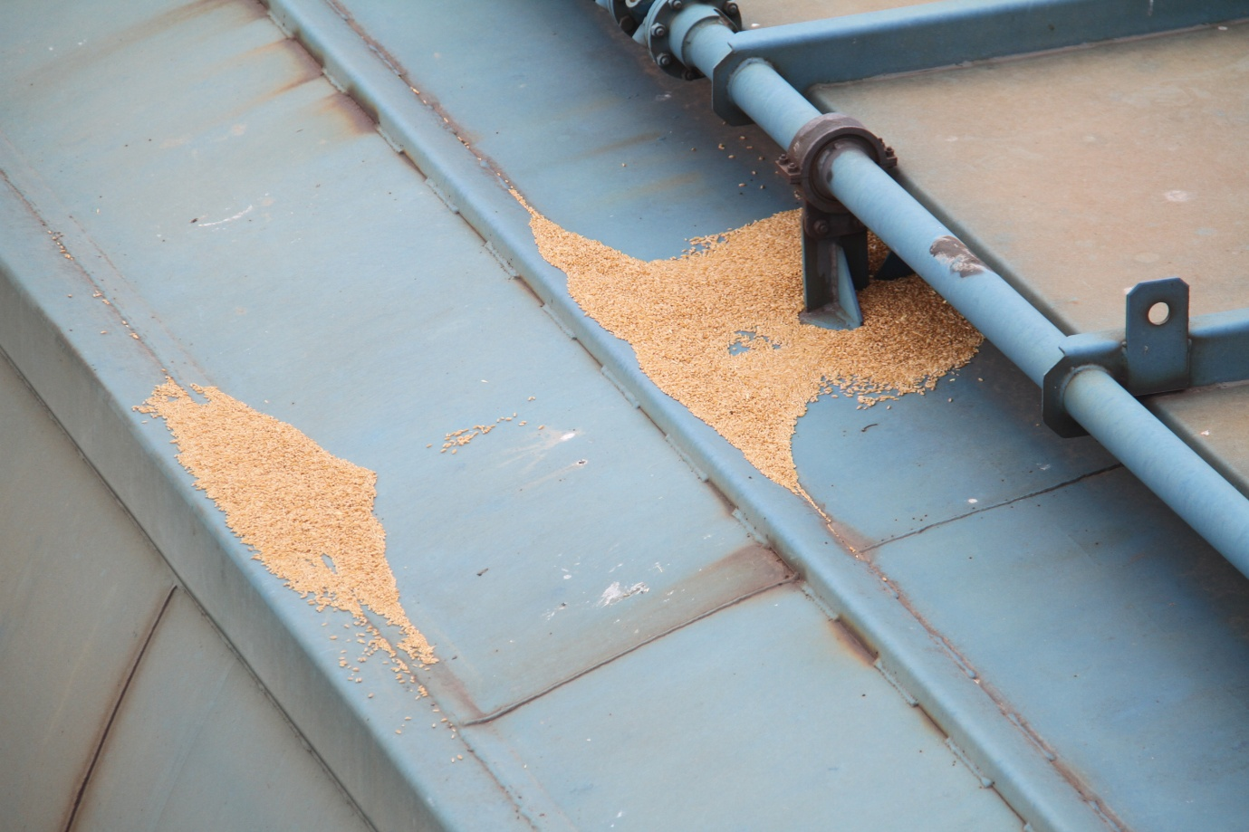
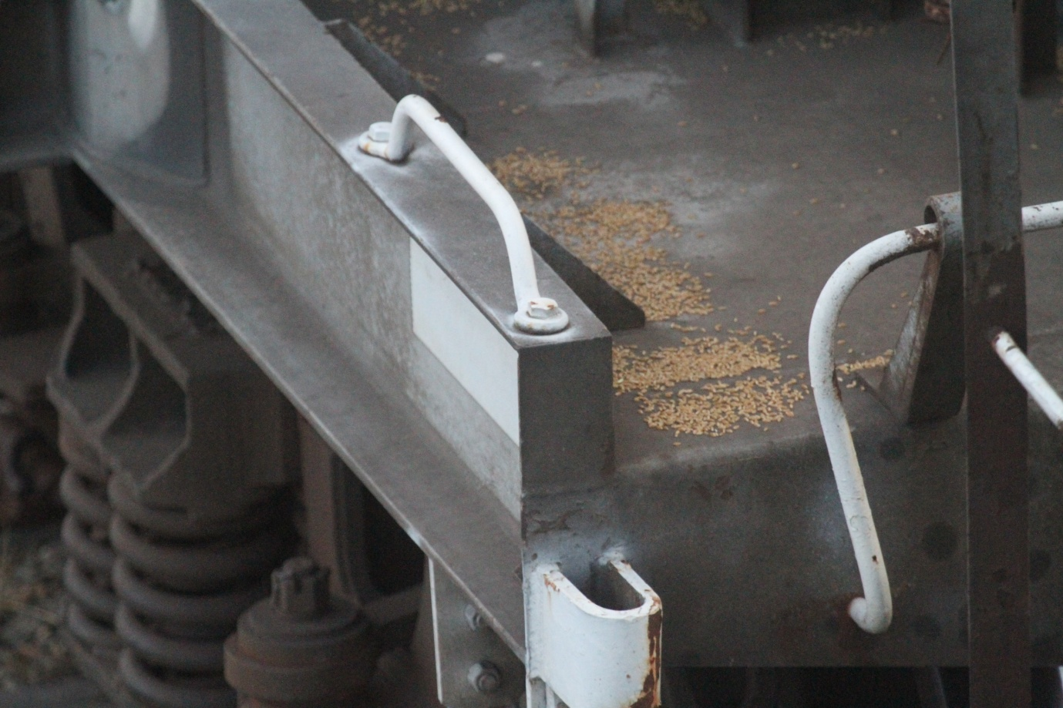
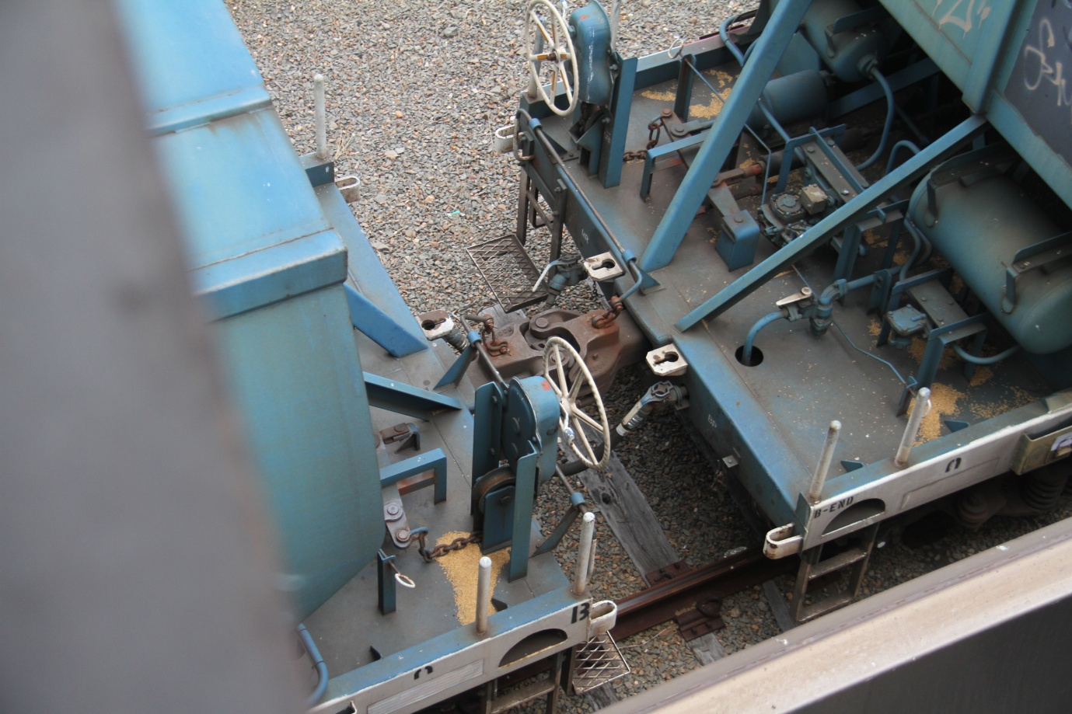
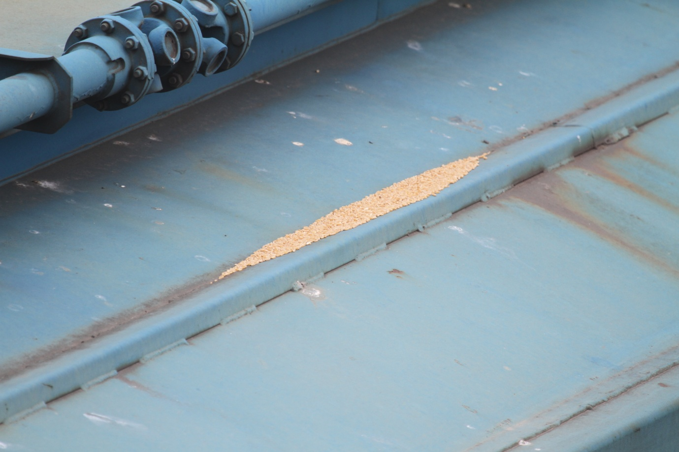

Grain dust is a hazardous material and is a significant cause of asthma, allergies and other lung diseases.
The lids of grain trains are carriers of a wide range of particulate matter including dust, grit, organic matter and metals.
The fitment of lids on coal wagons are likely to replicate the pollution issues exhibited by grain trains. Final design of future coal wagon lids may clarify the outcome.

Photos
Rick took about 120 photos on the day however only about 15 are reproduced below due to a data corruption issue with the memory card. Efforts are being made to recover all the photos and all the photos will be forwarded shortly.
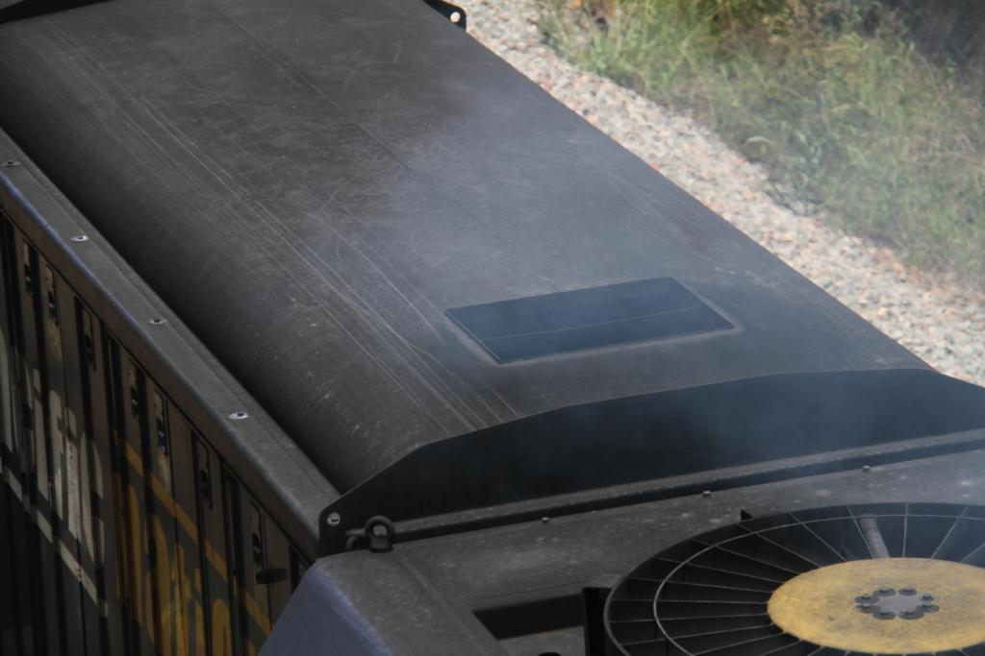
Loco exhaust outlet and stained roof. Obvious emissions.
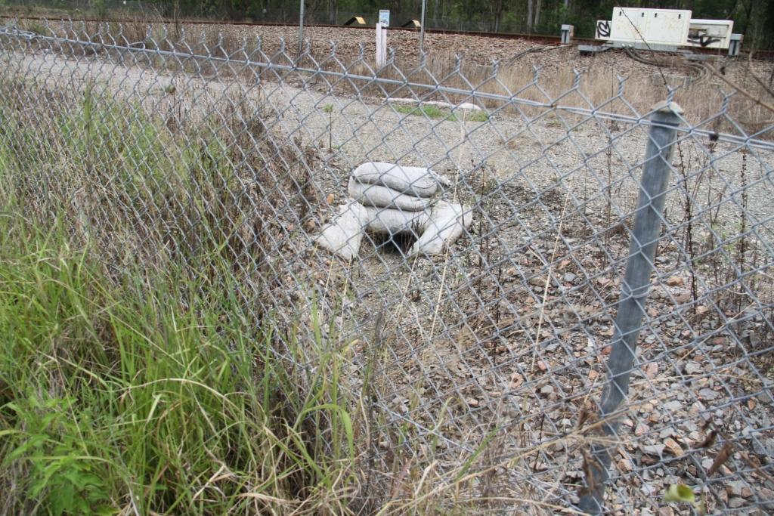
The open drain at Metford that drains corridor water off site.
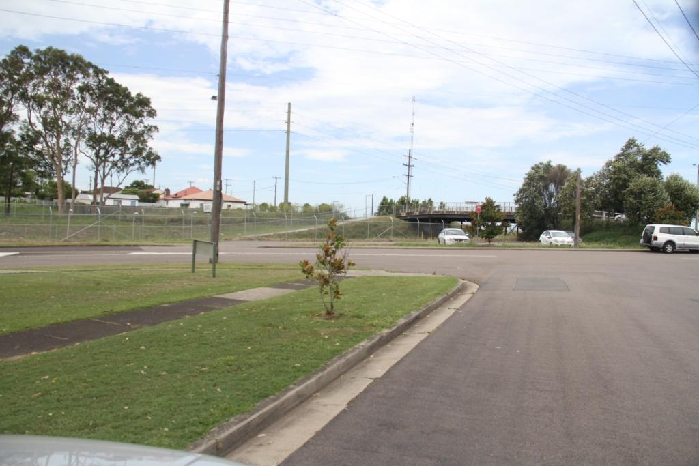
The Beresfield car park where the monitor was located
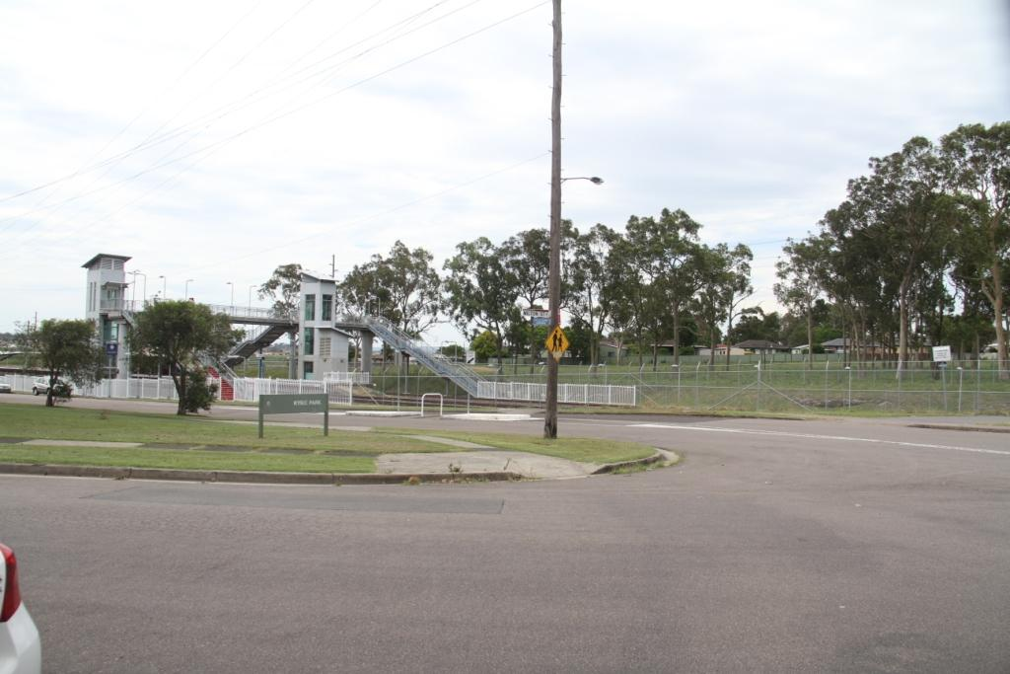
Site location of CTAG monitor at Beresfield

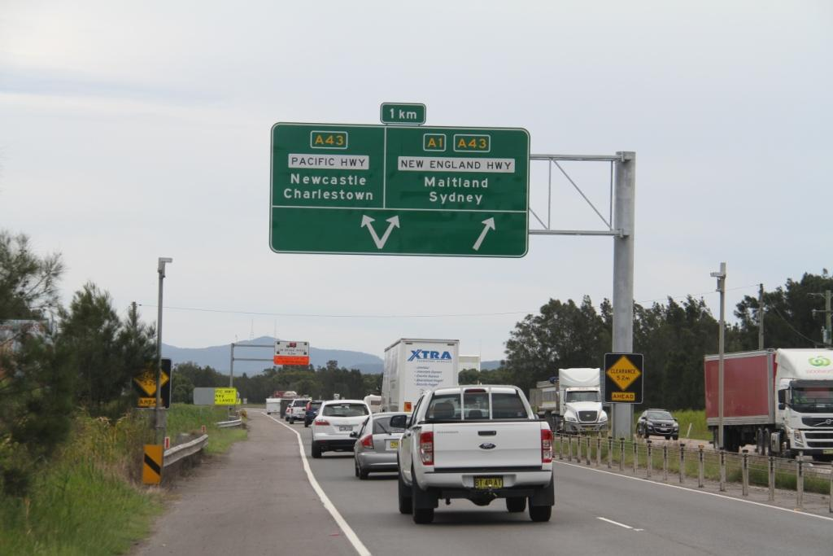
The over height light beam at Hexham. The two small poles on either side of the big sign have the sensors. When the truck breaks the beam the second sign further down the road instructs drivers on actions to take.
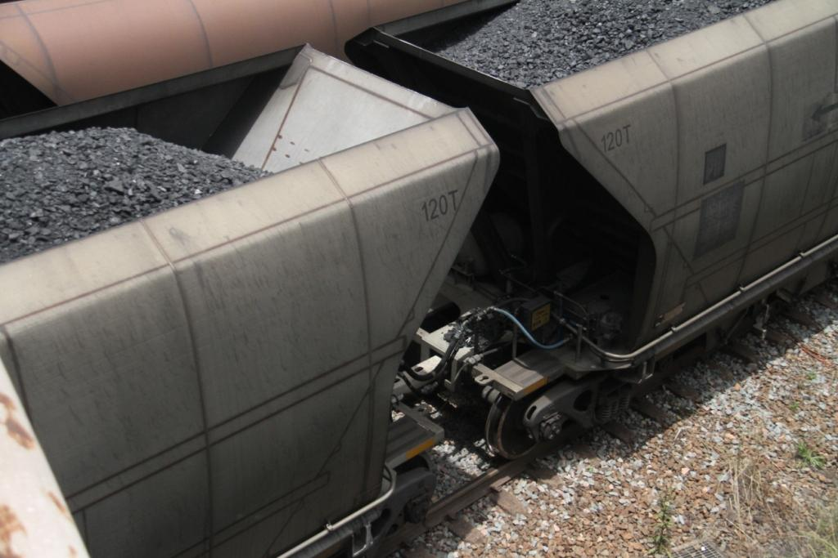
Wagon showing platform coal, poor loading and sticky coal fines on the wagon interior and exterior.
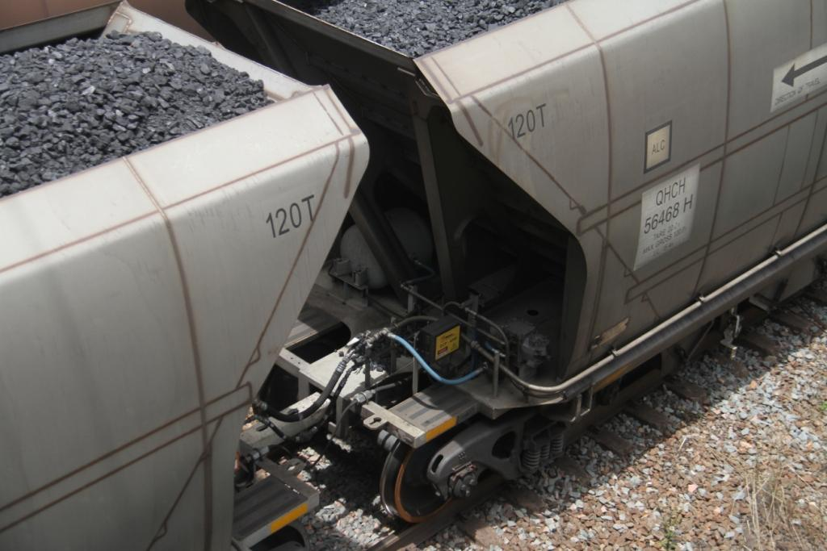
Photo shows wagon numbering and coal (after slumping) close to flowing over the rear of the wagon.
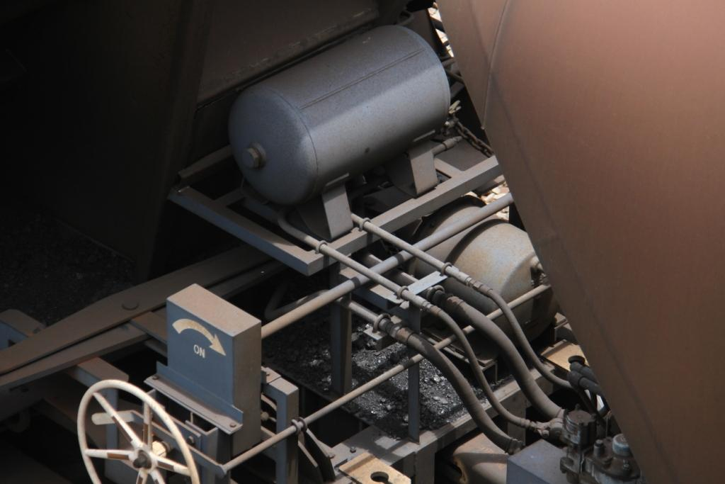
Coal waiting to fall on to the tracks
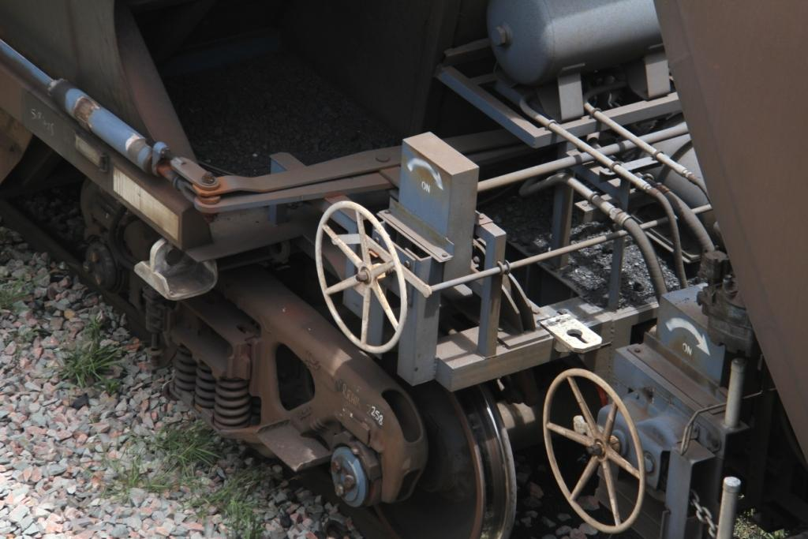
Large quantity of coal on the platform
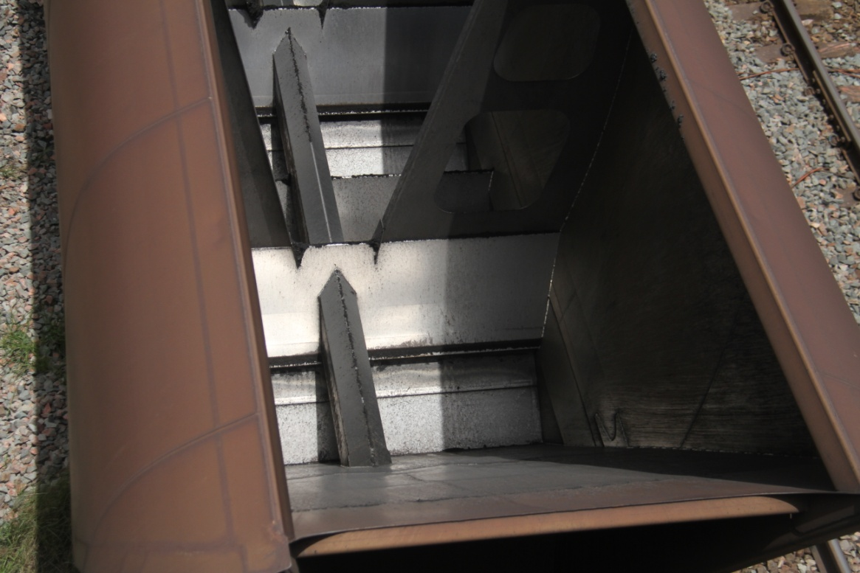
Coal wagon with residual coal and wet fines material clinging to the internal walls.
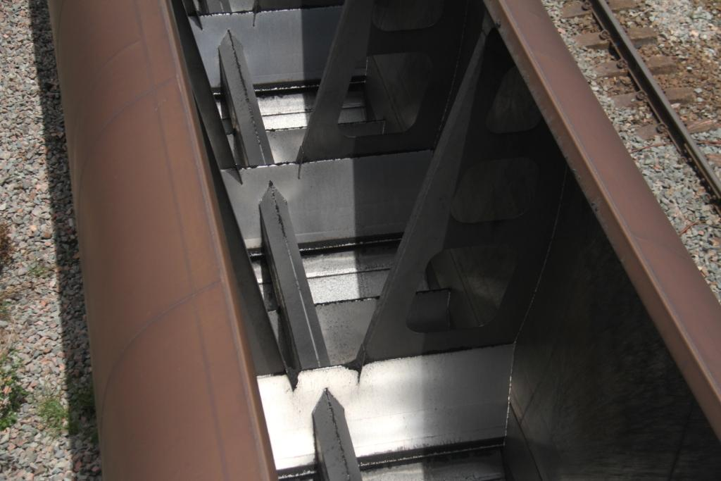
Coal wagon showing residual coal
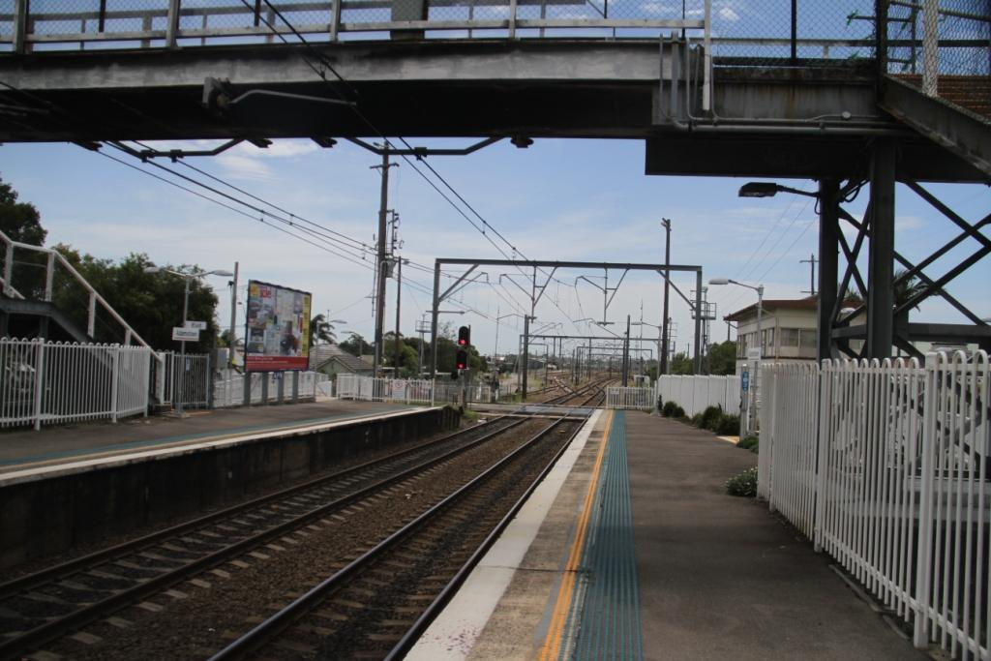
Adamstown Station looking North to the Broadmeadow yards. Tracks carry Electric Intercity passenger trains and Diesel coal and freight trains. Also shows Adamstown rail crossing.

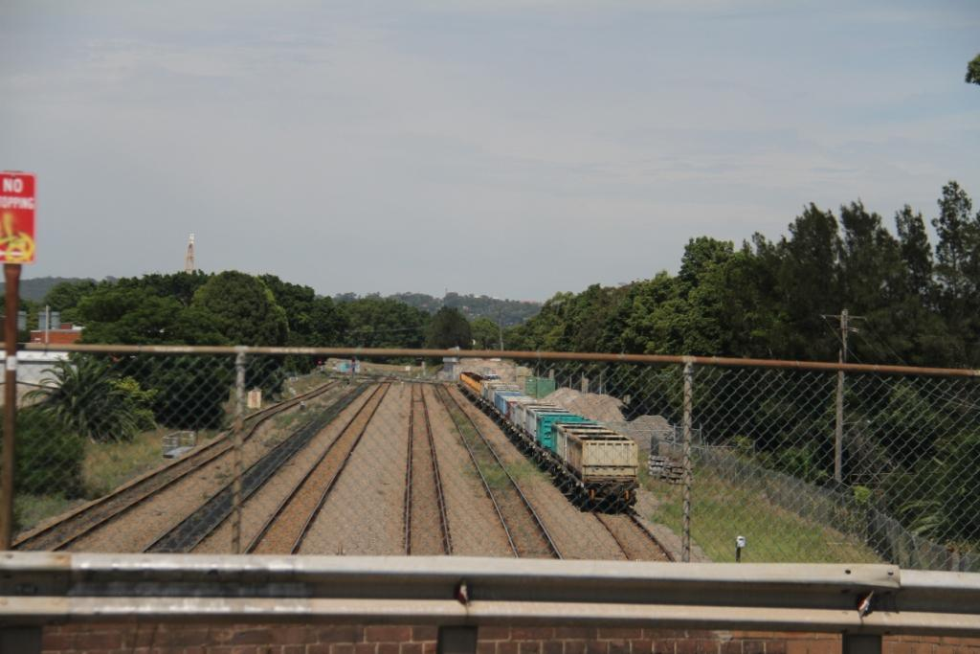
Freight wagons similar to minerals wagons. Note the unloaded coal wagon track second from the left
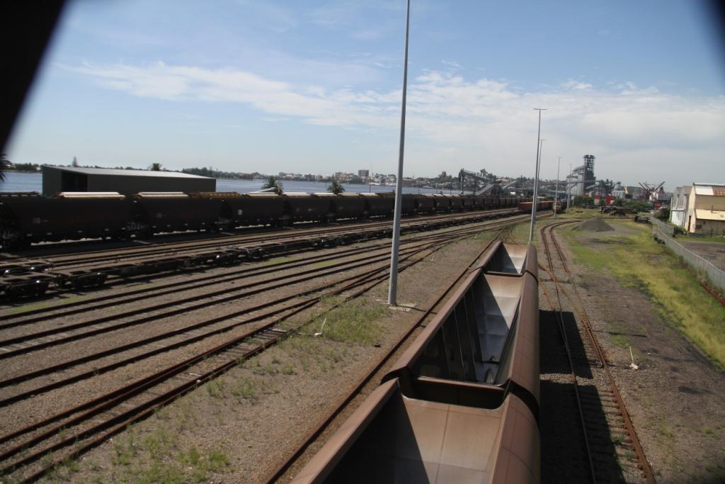
Grain train on left with damaged lids as observed
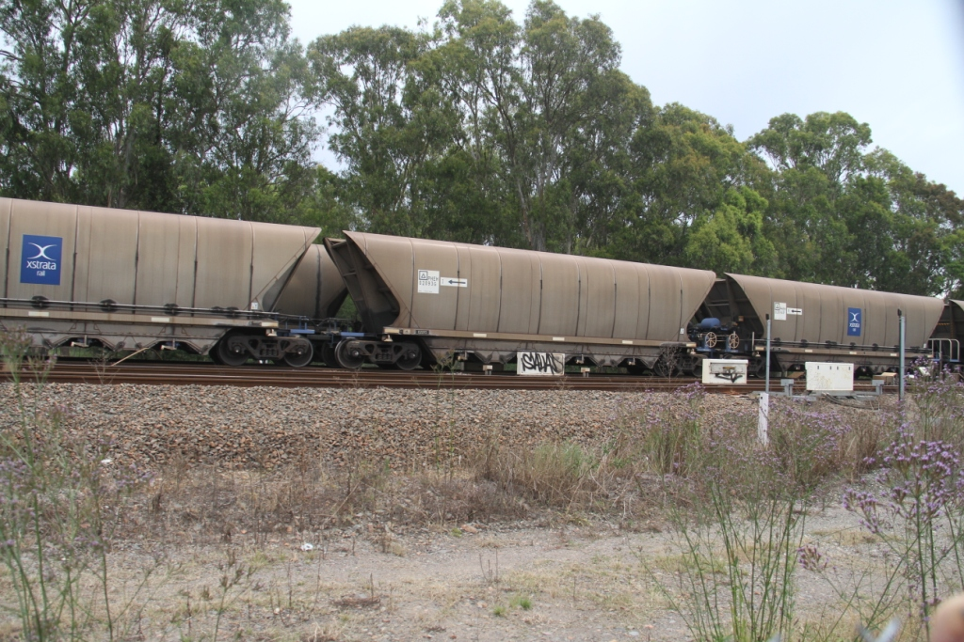
A loaded eastbound train passing a west bound unloaded train

